AA
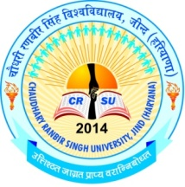
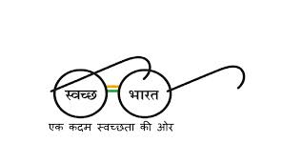

PROSPECTUS
For Admission to M.Ed (Regular) Two Year (Four Semester) Course
(Session-2018-19)

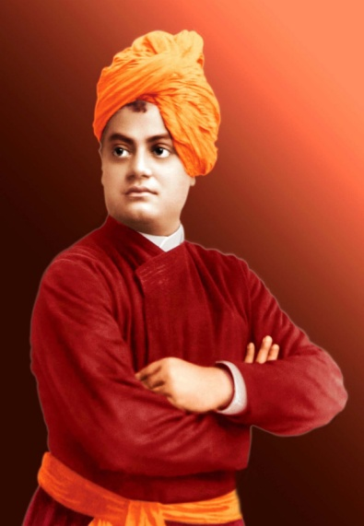
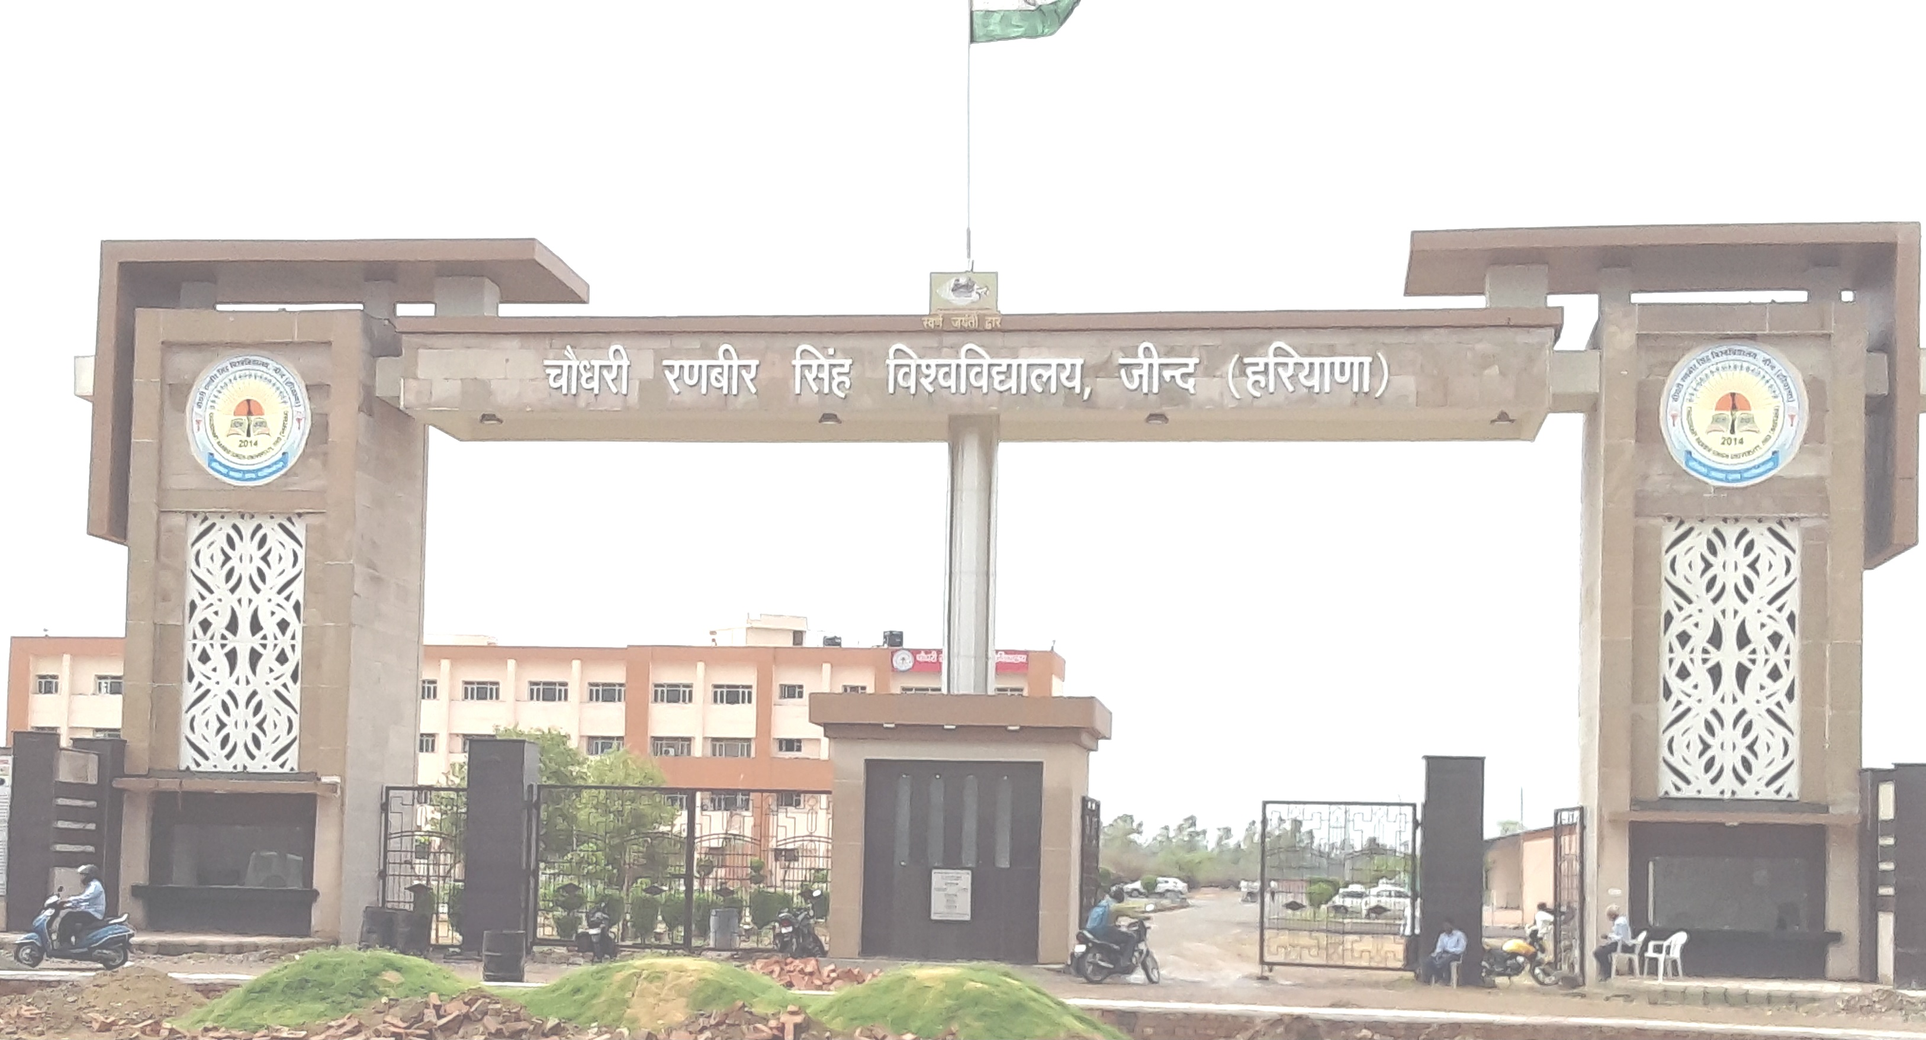

CHAUDHARY RANBIR SINGH UNIVERSITY, JIND
(Established by the State Legislature Act 28 of 2014 and recognized by UGC U/S 2(f) & 12-B of its Act 1956)
www.crsu.ac.in

AUTHORITY
The Additional Chief Secretary to Govt. of Haryana, Higher Education

(Established by the State Legislature Act 28 of 2014 and recognized by UGC U/s 2(f) & 12-B of its Act, 1956)
www.crsu.ac.in

From the Vice Chancellor’s Desk
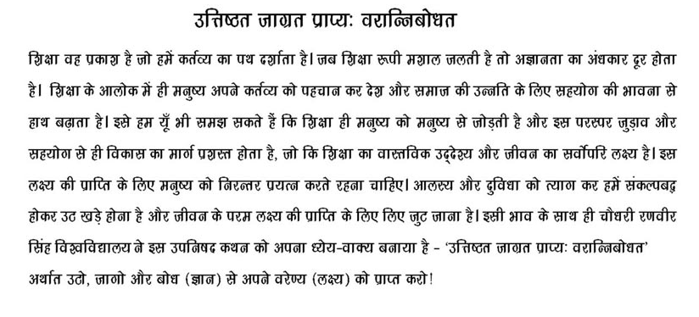
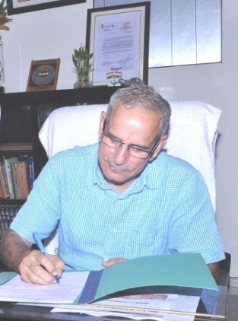
(Chaudhary Ranbir Singh University, Jind)
Born on 24 July 2014, a hardly three years old university has boast of many landmark achievements in various fields like Academics, Sports, Cultural Activities and social outreach. The University began with 16 UTD’s on campus offering 22 courses in different disciplines ranging from Diploma to Ph.D., albeit the university is situated in the vicinity of backward and rural region of Haryana, but the progress and growth it has registered during this period is tremendous, owing to which the Govt. of Haryana entrusted the University with the responsibility of conducting online admissions to B.Ed (Regular) Course for the academic session 2018-19 in all the colleges of education in Haryana. The University, besides offering various post- graduate courses is also planning to start a model B.Ed College at the University Campus. The University has developed a rich library, three well- equipped computer labs, and a Language Lab with all modern facilities and Internet connectivity through fiber Network. With the help of continuous comprehensive education system and experienced teachers, I am sure, the University will be able to produce excellent future academic cream of the crop of teachers. It is true that “No nation can rise beyond its teachers”, but it is also true that a great teacher takes pride when his students excel him. The main focus of the University will be to enable teacher trainees to realize and develop their potentials and possibilities and inculcate moral values enshrined in Indian tradition, so as to acquire a holistic vision.
It is a matter of great pride that CRS University has achieved the distinction of being the first state university of Haryana with 100% biometric attendance plus the leading digital state university of Haryana with 14th Rank among the 4500 institutes all over India promoting cashless transactions as per the vision of Hon’ble Prime Minister. In recognition to these achievements, the Hon’ble Human Resource Development Minister Govt. of India gave an outstanding award to the University for implementing “Vitiya Shaksharta Abhiyan” of Hon’ble Prime Minister. The University aspires to come upto the dreams of great personalities like Swami Vivekanand & Hon’ble Dr. APJ Abdul Kalam, former President of India to be among top 200 Universities of the World by 2020. The University is working hard towards achieving innovative thinking, a spirit of Scientific Enquiry, and Human values with Democratic Ethos so as to carpet the society instead of putting on slippers. It is committed to make its students a better human being before becoming a professional, in their respective fields.
The University is committed to promoting Government programmers like “Swachh Bharat, Swasth Bharat”, “Beti Bachao Beti Padhao”, “Yoga and Sports, Value Education” and the likes and creating a sense of awareness in the masses towards these programmes. I call upon everyone to join hands in making all these drives a mass movement.

Prof. (Dr.) R.B. Solanki
Vice Chancellor
CRS University, Jind.

CONTENTS

- Statutory Officers 1
- Vision and Mission of the University 2
- University profile 3-8
3. Important Dates 9
4. Online Schedule 10
5. Important Instructions at a Glance 11-12
6. Instructions for Colleges 13
7. Eligibility Conditions and Fee Structure 14
8. Online Admission Procedure 15-18
ANNEXURES
I) Bonafide Residents of Haryana: Guidelines 19-20
II) List of the Scheduled Castes in Haryana State 21
III) List of Backward Classes in Haryana State 22
IV) Scheduled Caste Certificate 23
IV(A) Backward Classes Certificate: Block A or B 24
V) AFFIDAVIT (by the Parents of the Backward Class Category candidates) 25
VI) Medical Certificate for Physically Handicapped 26
(O/o the Chief Medical Officer)
VII) Certificate to be furnished by Children/Grand Children of Freedom Fighters 27-28
VIII) Haryana Resident Certificate (for Bonafide Residents of Haryana only) 29
IX) Certificate from the Employer (in the case of employees of 30
Govt. of Haryana, Members of All India Services borne on
Haryana Cadre, Employees of Statutory Bodies/Corporations).
X) Letter of Govt of Haryana dated 05-12-2008 31
CWP No. 12231 of 2007 Suman Rani V/S MD University Rohtak.
XI) Character Certificate 32
XII) Affidavit to be submitted by students against ragging at the time of admission 33-34
XIV) Distribution of Seats for Self-Financing Education Colleges offering the M.Ed. Course 35
XVI) NCTE Guidelines regarding eligibility 36
XVII) List of Fake University / Institutes / Boards 37
XVIII) List of Colleges of Education pffering the M.Ed. Course for the Session 2018-19 38-39

Establishment of Bharat Bodh Gallary in the University

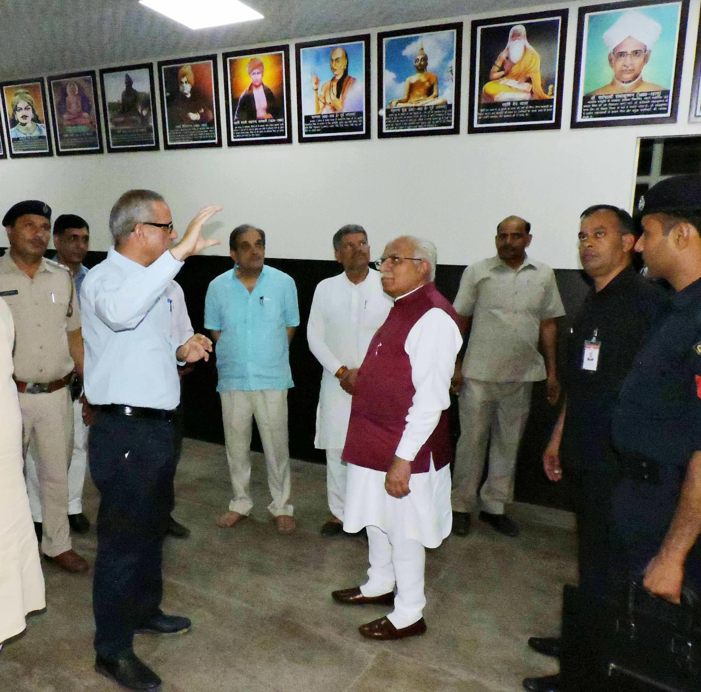

Hon’ble Chief Minister, Haryana, Sh. Manohar Lal and Hon’ble Cabinet Minister, Govt. of India, Chaudhary Birender Singh visited the Bharat Bodh Gallery on 27-05-2018.

STATUTORY OFFICERS
Hon'ble Chancellor
Shri Satyadeo Narain Arya, Governor, Haryana

Vice-Chancellor Prof. (Dr.) R.B. Solanki 01681-254569 (O)
01681-254569 (Fax)

Registrar Dr. Rajbir Singh 01681-256852(O)
01681-256852(Fax)
Proctor and Dean of Students’ Welfare Prof. Sandeep Berwal 01681-241023 (O)

Chief Warden Dr. Jyoti Sheoran 01681-241018 (O)

Dean Academic Affairs and Dean of Colleges Prof. S.K. Sinha 01681-241033 (O)
01681-241030(O)

Controller of Examinations Dr. Rajesh Kumar Bansal 01681-241003 (O)

Finance Officer Dr. Ravi Bhushan 01681-241017

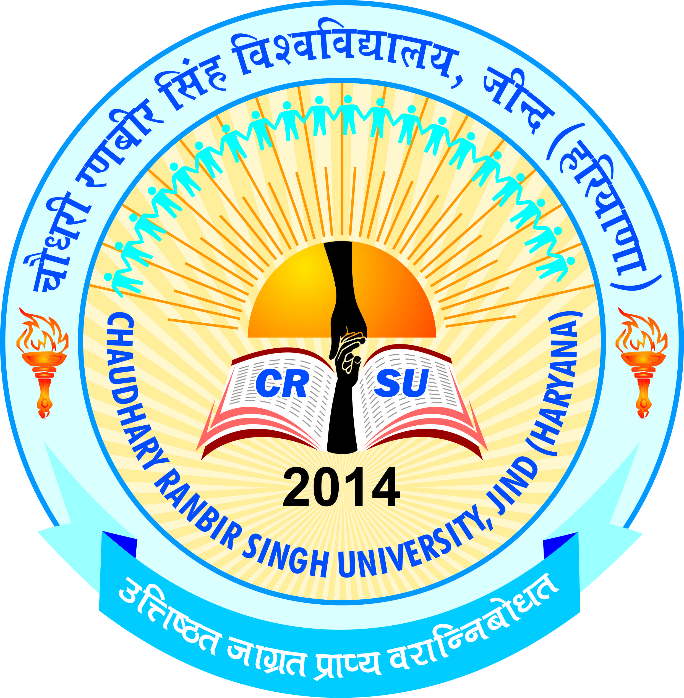 | pkS/kjh j.kchj flag fo'ofo|ky;]thUn  Chaudhary Ranbir Singh University, Jind  (Established by the State Legislature Act 28 of 2014 and recognized U/S 2(f) & 12-B by UGC Act 1956) | 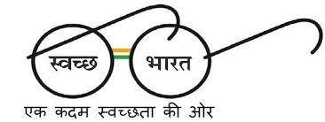

Vision of the university
- To create the most conducive ambience for the creation and dissemination of knowledge guided by innovative thinking, scientific enquiry, sublime human values, sustainable ecology, and democratic ethos.
- To be among top 200 Universities till 2020
Mission of the university
- To celebrate the national traditions, culture, heritage and folklore.
- To focus on quality, relevance and innovation in each discipline.
- To establish linkages with reputed organisations at national and international level for the exchange of ideas and collaborative research.
- Student-centric and participatory academic environment.
- To maintain coordination with various stakeholders including Government, Industry, Community etc.
- To inculcate sound human values
- To practice multidisciplinary and inter-disciplinary approach in dissemination of knowledge.
- To impart soft skills to ensure employability.
- Zero tolerance for indiscipline and irresponsible life style.
- To create world class infrastructure to facilitate students to engage in rigorous academic originality in research activities.
- To contribute to the development of the neighbouring community through social outreach initiatives.

UNIVERSITY PROFILE

Established by the State Legislature Act 28 of 2014 on July 24, 2014, CSRU has a sprawling campus of 75 acres situated 2 kilometres from Gohana Bypass, Jind. The university was established with the vision of imparting quality education by creating most conducive ambience for the production and dissemination of knowledge guided by innovative thinking, scientific enquiry, sublime human values, sustainable ecology, and democratic ethos. The aim of the University is the cultivation of citizens with a rich awareness of our heritage to lead and serve in every sphere of human activity. Working under the leadership of eminent educationists and social reformers, Hon'ble Chancellor Shri Satyadeo Narain Arya and dedicated, dynamic and devoted personality Vice- Chancellor Prof. R.B. Solanki, the University is heading towards realization of its vision and the goal of being in the world ranking by 2020.
The University is affiliated u/s 2(f) and 12 (B) of the UGC Act, 1956 vide letter no. 9-12/2014(CPP-I/PU) dated 26 September, 2014 and is also a member of the Association of Indian Universities. In a short span of four years, the university has many achievements to its credit. The First Convocation of the University was held on April 18, 2017. Prof. Kaptan Singh Solanki, Governor of Haryana was the Chief Guest and delivered the Convocation Address. Ch. Birender Singh, Steel Minister, Government of India, Sh. Ramesh Kaushik, Member of Parliament, Smt. Prem Lata, MLA and Sh. Jasbir Deswal, MLA were also graced the convocation as Guests of Honour. The university gave 14 Gold Medals, 13 M.Phil, 289 Post Graduates and 289 Under Graduates Degrees were awarded during the Convocation.
In addition to the academics the students are also encouraged to participate in sports events and extracurricular activities at the campus as well as outside the campus the enable their wholesome personality development.

The university has a newly constructed academic block with latest infrastructure and newly constructed Laxmi Bai Girls Hostel with ultra-modern facilities. The central library of the university has the stock of approximately 16000 books. It subscribes to National and International refereed journals, magazines and periodicals and also subscribes many Hindi and English newspapers. Round the clock internet facility is also available in the library premises. The university has an impressive Language Lab which is open for all the students of the university to help them to improve their communication skills. The university also has a Computer lab well equipped with the latest software and is networked with 32 mbps internet speed with fiber optical device. The Psychology lab of the university is spacious and fully equipped with latest equipment to carry out the tests. The Conference room of the university is equipped with world class facilities with a seating capacity of 40 persons. The construction for the extension of academic block, Second Computer Lab, Administrative Block, Boys Hostel, Sports Stadium and residential quarters for faculty is in full swing. The students of this university have shown commendable results in academics as well as co-curricular activities. With the present pace of progress, the university looks forward to having a promising future.

UNIVERSITY LIBRARY

Libraries are an integral part of all educational institutes in India. The library of the university is well equipped with large numbers of books. The library has subscribed many newspapers. It is planned to shift the library to its new building from the coming session i.e. 2018-19. It will be well equipped with the modern technology and infrastructure. Recently, an E-Kiosk system has also been installed for the convenience of the students as well as faculty members. The library also provides AC reading rooms where the readers can study peacefully. The library remains open from 9.00 A.M. to 5.00 P.M. The library recorded about 500 users including students and staff of the university.

LAXMI BAI GIRLS' HOSTEL AND CHHATRAPATI SHIVAJI BOYS' HOSTEL

The University has one hostel for Girls named after the Queen of Jhansi, Rani Laxmi Bai. It was inaugurated by Hon'ble Governor Prof. Kaptan Singh Solanki on 12th November, 2014. It has the capacity of accommodating 240 girls. The University has one Hostel for Boys named after the Founder of Maratha Empire, Chhatrapti Shivaji Maharaj (Shivaji Raje Bhosale). It was inaugurated by Hon’ble Chief Minister Sh. Manohar Lal on dated 27th May, 2018. It has the capacity of accommodating 180 boys. The hostel is provided with electronic gadgets including electric geysers, 32" Plasma TVs along with Dish/DTH facility and water cooler with RO system. The hostels subscribe to several national and regional dailies and magazines for enabling the students to know what is happening around the world. Sport facilities for girls include table tennis and badminton court, volley ball court, gym and different indoor games like carom-board and chess etc. Medical facilities to all hostel residents are provided through the University Health Centre located in the Hostel premises. The University also has a Horticulture Club maintained by the girls of the Hostel. Beauty and skin care clinic has been established for the grooming of all students. The hostel on the campus operates its own mess providing hygienic and nutritious meals with a varied menu. In view of the large number of students applying for hostel accommodation, the university allows hostel to the students on the basis of merit.

UNIVERSITY HEALTH CENTRE

The Health Centre located in Laxmi Bai Girls Hostel has sufficient space for a dispensary with patient Beds and stools with drop stand. The centre has a visiting doctor and a nurse and provides medical consultation and free medicines to all students and staff. The health centre is well equipped with all basic apparatus and general medicines. The Health Centre also provides first line of treatment in emergency cases. The process for the full-fledged development of university health centre is in process and will be accomplished soon.

UNIVERSITY COMPUTER & INFORMATICS CENTRE (UCIC)

The University Computer & Informatics Centre (UCIC) is steadily evolving the university as "Digital University" and working rigorously to provide the excellent infrastructure facilities with High end systems controlled by Dell Make power Server. Central UPS with a power back up of 8 hours is controlling all the All-In-One Systems connected via optical fiber LAN covering the whole Campus. 24 X 7 Internet facility with 32 Mbps is available to students as well as staff. UCIC is continuously monitoring and updating all the information on university website as well as on various social media portals. It also purports to automate administrative and secretarial wings of the university with the aim to cater the needs of the entire university. University Computer & Informatics Centre (UCIC) is providing opportunity to enhance professional knowledge of students.

LANGUAGE LAB
The Language lab has been established to improve communication skills of the students. The Lab is equipped with latest software related to English Language and Communication. It provides a host of opportunities for students to work with online exercise sheets and virtual practice sessions, thus enabling them to learn language in a simulated environment.
PANDIT DEEN DAYAL UPADHAYAYA CENTRE
In order to prepare students for varied professional fields, the university has established DDUC for university students as well as students/professionals from other institutions. The Cell has implemented the following schemes (i) Free UGC NET coaching (ii) Personality Development Capsule (iii) SSB coaching. Faculty members, teachers from other universities and experts from different fields are also invited to deliver extension lectures in the centre.
SC/ST CELL

The SC/ST Cell has been established for the welfare of SC/ST students of the university as per the instructions of the UGC/State Government. The Cell also functions as a Grievances Redressal Cell to redress the grievances of the SC/ST students and employees of the university. It also counsels them in solving their academic as well as administrative problems. The main objective of the SC/ST Cell is to ensure proper implementation of various schemes of University Grants Commission/Government of India/State Government introduced from time to time.

GUIDANCE AND COUNSELLING CELL

The university has constituted Guidance and Counseling cell to assist the students in career areas (Knowledge of different career options through Career Talks). It also helps students in Personal areas (Stress, anxiety, lack of self- confidence, communication skills, Development of Positive attitude, Assertiveness Training, etc.).
EQUAL OPPORTUNITY CELL
The university has constituted Equal opportunity cell to provide equal opportunity to all including the persons with disability. In addition, it will also examine all the possible ways in which SC/ST, OBC and all other minority groups could be helped.

VIGILANCE CELL

The university has constituted Vigilance cell to activate vigilance machinery for investigating complaints and sensitizing the university community against corruption and corrupt practices. The main objective of this cell is to prevent the possibilities of corruption and to encourage a culture of honesty and integrity.

RESEARCH CELL

The university has constituted the Research Cell to facilitate and promote quality research in emerging areas of higher education with focus on new frontiers and to act as a knowledge power- house capable of contributing to the national development and welfare of the society.

INTERNAL QUALITY ASSURANCE CELL

The university has constituted the Internal Quality Assurance Cell (IQAC) for planning, guiding and monitoring quality enhancement activities of the University. The cell works to instill the spirit of quality consciousness and continuous improvement of academic and administrative performance of the University and to promote measures for institutional functioning towards quality enhancement through internalization of quality culture and institutionalization of best practices. In order to enhance the academic quality of the UTDs, the auditing of the departments is carried out from time to time. The university invites experts who suggest areas where the department needs to improve. All the internal audits are discussed in the meetings chaired by the Vice Chancellor, who provides directions for the implementation of the suggestions of the experts given in the audits.

DIRECTORATE OF YOUTH AND CULTURAL AFFAIRS
Directorate of Youth Welfare aims at ensuring the welfare of students by conceiving and organizing programmes for the establishment of a healthy cultural environment in the university. It motivates students to participate in various cultural activities to ensure their holistic development. Besides celebration of national festivals, the Directorate also organizes Talent Hunt Competitions.
SPORTS ACTIVITIES

Sports activities of the university are being run under the Sports Council. The university has the following playfields: Handball (1), Football (1), Volleyball (1), Netball (1), Korfball (1), Kho- Kho (1), Kabaddi(1), & Athletic Track 400 mtrs. The university is going to have its Sports Stadium soon. The university provides different sports facilities to its players taking part in the inter university tournaments like free TA & DA, sport kit &track suit, free medical facility and scholarship to the players winning positions in these tournaments. In recently completed Asian game 2018 (18 Aug 2018-2 Sept 2018) at Jakarta, Indonesia. One student of Department of Education namely Ms. Ritu participated as a member of Handball team and represent the Country.

NATIONAL SERVICE SCHEME

National Service Scheme (NSS) promotes the spirit of voluntary work among the students and teachers through sustained community interactions. It brings academic institutions near to the society. It shows how to combine knowledge and action to achieve results, which are desirable for community development. NSS at Chaudhary Ranbir Singh University was established with the objective of providing the youth an opportunity to develop their overall personality by taking part in various Social Service Schemes. The University has initiated the process of students' enrolment. Students will be given opportunity to participate in state and national level camps. Merit certificates are provided to students, who perform well in the camps. The NSS unit organized special camp on digital financial literacy and four students also received appreciation from MHRD, Government of India.

BHARAT BODH GALLERY

The University has established Bharat Bodh Gallery for inculcating the values of National Pride and National Commitment, Teaching to live together for Social Harmony, Education about Bhartiya Sanskriti, Bhartiya Gyan and Gouravshali Bhartiya Itihas among students.

Highlights of Activities

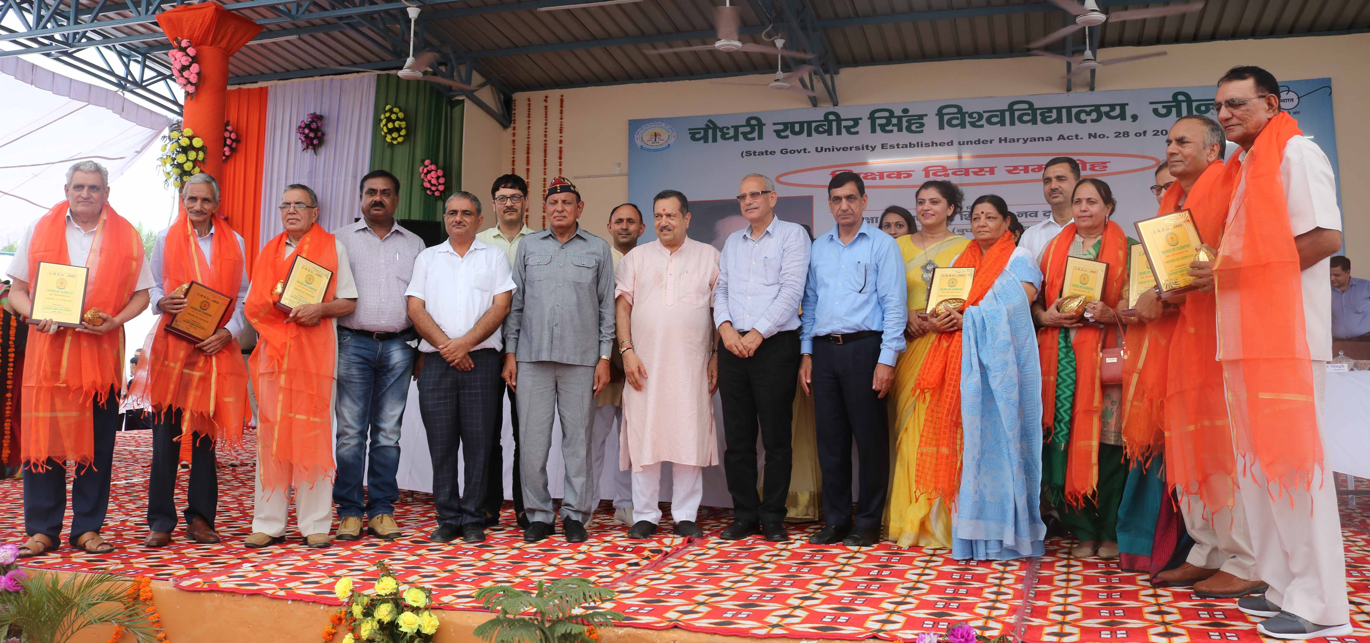
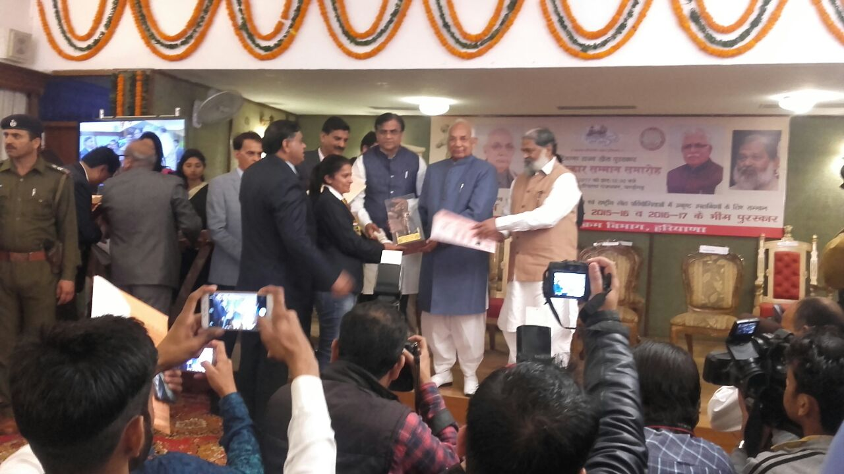

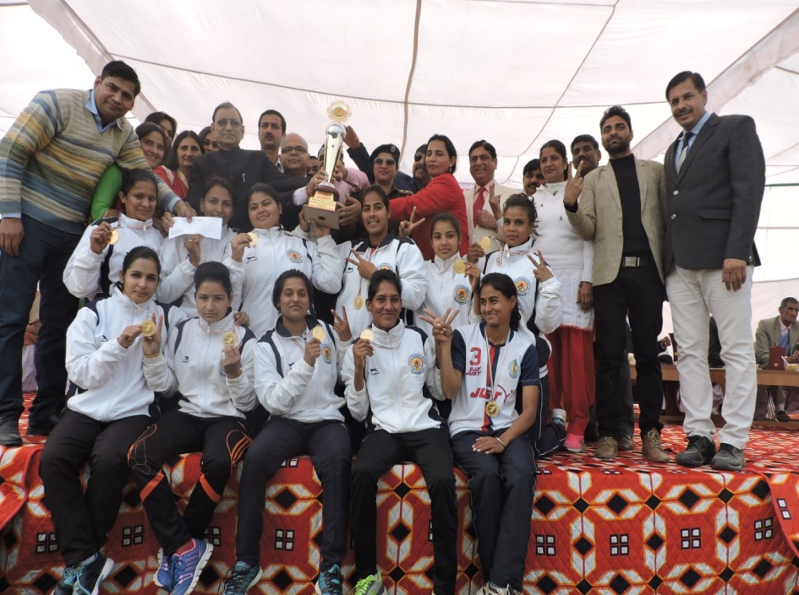
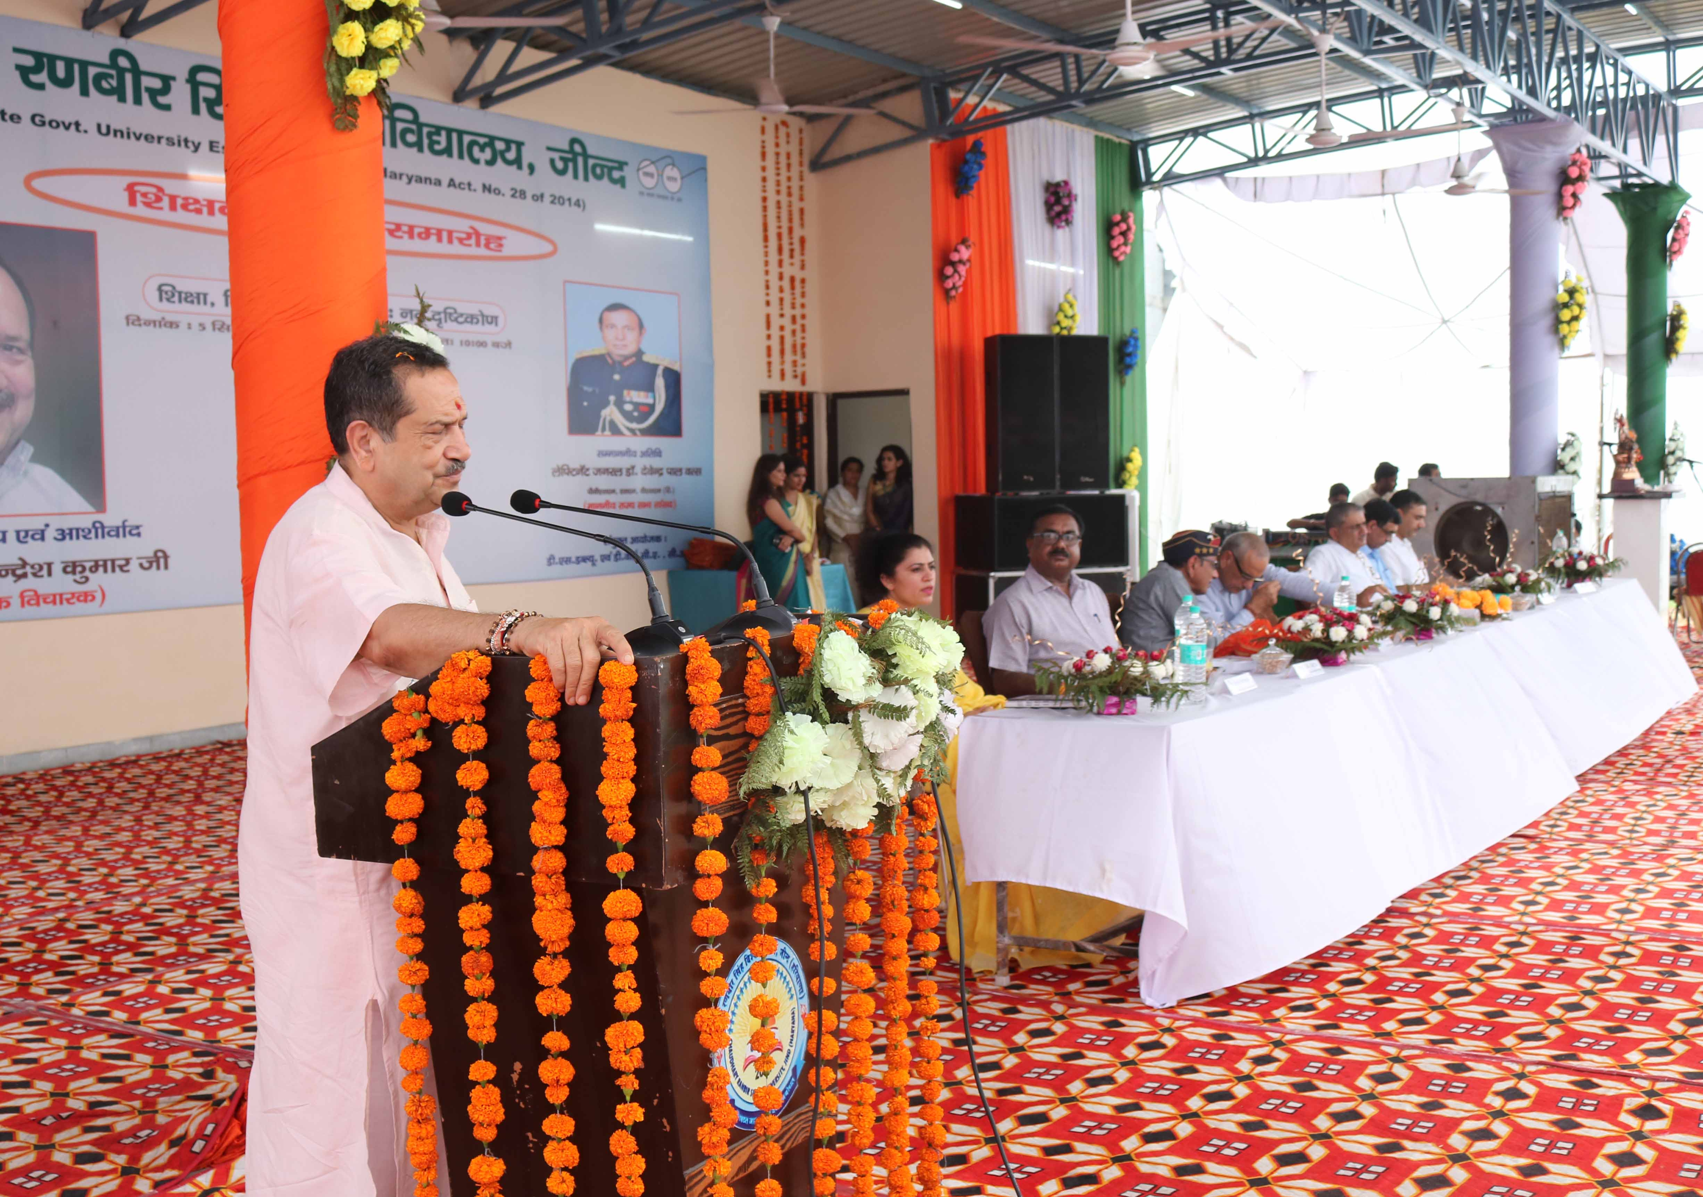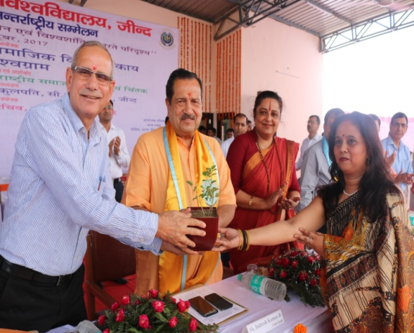

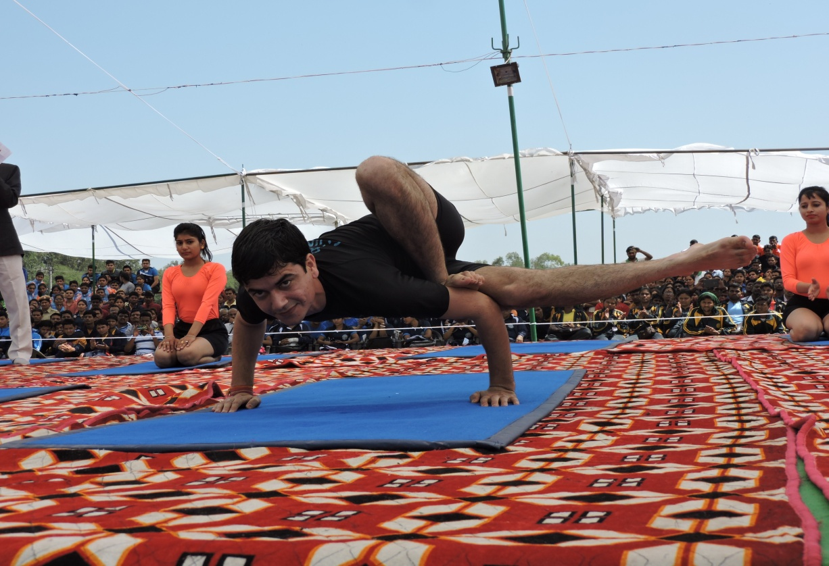
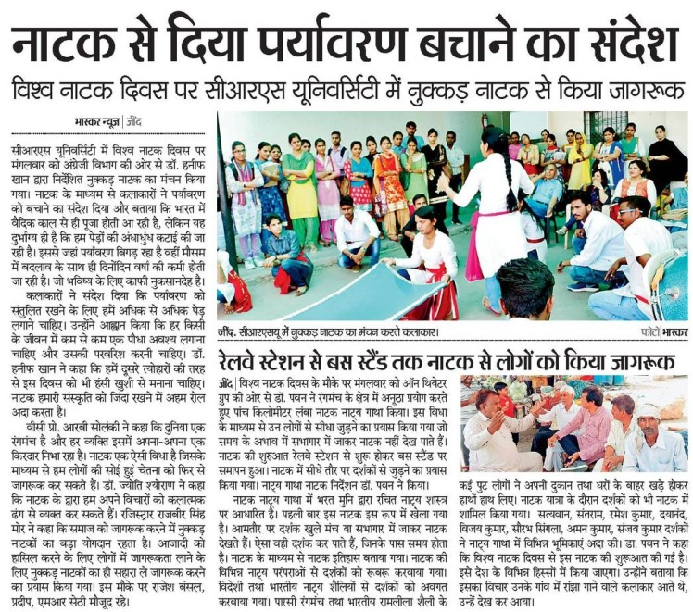
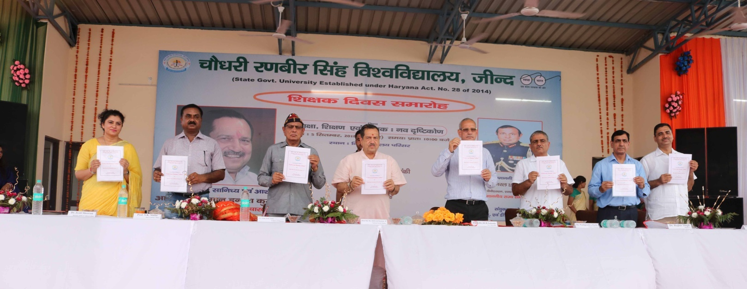

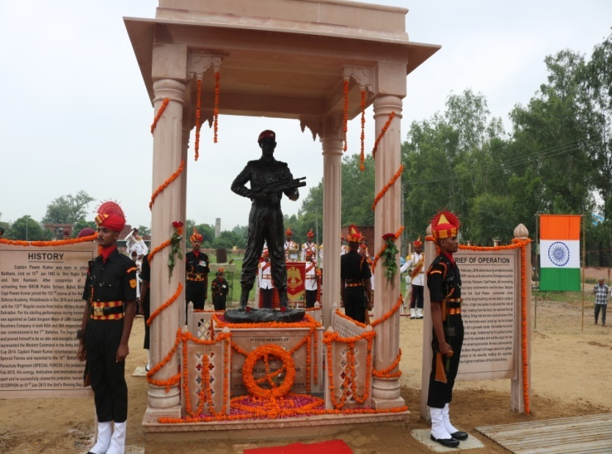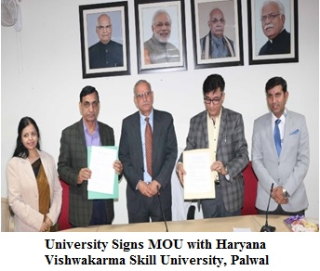
1st University Youth Festival “AAGAAZ”
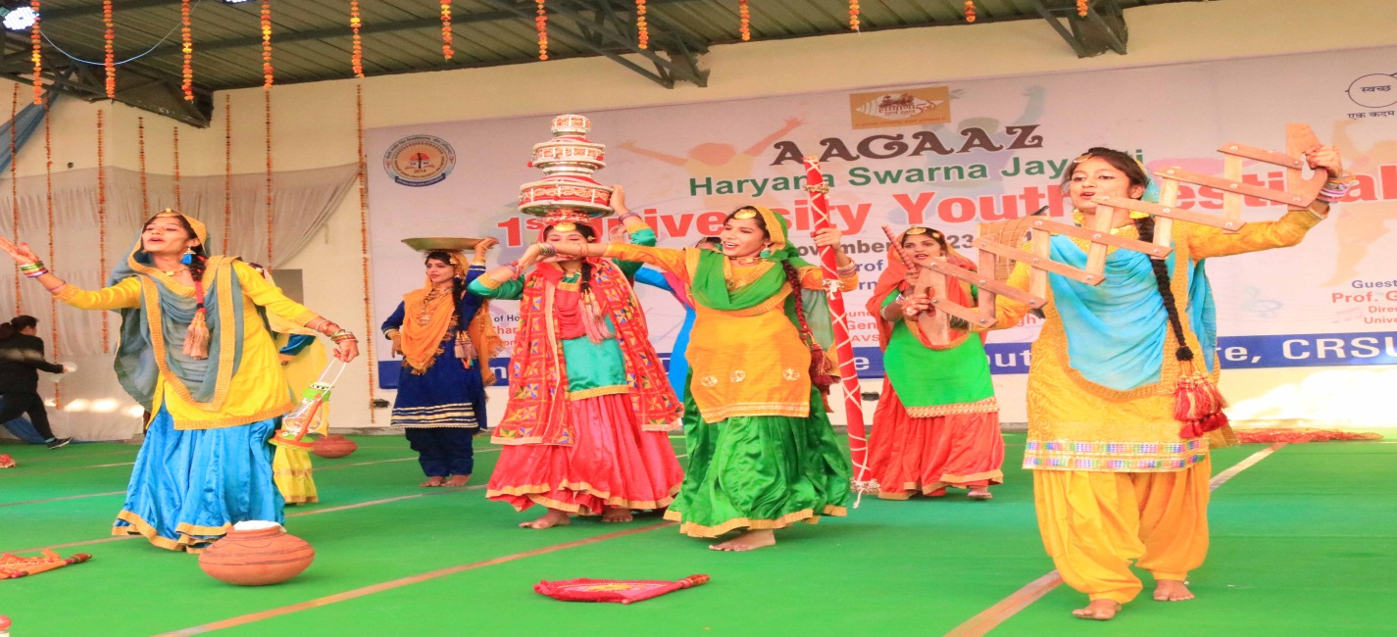
IMPORTANT Dates
The prospectus can be downloaded from University website i.e. www.crsu.ac.in, http://hrymed.com/,
w.e.f. 19TH October, 2018.

Online availability of Prospectus, Online Registration, acceptance of Applications | 19-10-2018
Display of merit list, Phase –I | 31-10-2018
Classes will start for the session 2018-19 | 05-11-2018
Tentative Month for Semester Examinations | March, 2019

Admission Helpline’s – Will be displayed later on .

University Contact No. – 01681-241033, 241030.
Email: deputy.registrarcrsu@gmail.com

ONLINE ADMISSION SCHEDULE

Details of Admission schedule | Candidate can apply for Phase-I for M.Ed. course under Self Finance Scheme (SFS) only
Online availability of Prospectus, online Registration, acceptance of 15.07.2015 25.07.2015  Applications, Deposition of Registration (upto 5-00 p.m.) (upto 5-00 p.m.)  as well as counselling fee of 1000/- (for  General category candidates) and 625/-  (for SC/BC/PWD and Girls candidates of Haryana only) | 19-10-2018 to 29-10-2018 ( upto 5:00pm )
Online choice filling and locking | 19-10-2018 to 31-10-2018 (upto 5:00pm )
Display of category-wise merit list of 18-07-2015 26-07-2015  the applicants | 31-10-2018 (after 5:00p.m)
Reporting of discrepancy, if any, by the 19.07.2015 to 27.07.2015 to  candidates & corrections thereof to be 20.07.2015 28.07.2015  incorporated | 31-10-2018 (after 5:00 p.m  to  01-11-2018 (upto 5:00pm)
PHASE-I FOR COLLEGES OF EDUCATION UNDER SELF FINANCING SCHEME
Online details of Counseling | 1st Round | 2nd Round | 3rd Round
Online availability of seats  allotment | 02-11-2018  (upto 5:00pm) | 06-11-2018  (upto 5:00pm) | 13-11-2018  (upto 5:00pm)
Candidates' personal reporting  at allotted college | 03-11-2018  (upto 5:00pm) | 08-11-2018  (upto 5:00pm) | 14-11-2018  (upto 5:00pm)
Online reporting by the college | 05-11-2018  (upto 5:00pm) | 12-11-2018  (upto 5:00pm) | 15-11-2018  (upto 5:00pm)
Classes will start for the session (2018-19) | 05-11-2018
Tentative Month for Semester Examinations | March, 2019

PHASE-II SUBSEQUENT COUNSELING FOR VACANT/LEFTOVER SEATS IN
COLLEGES OF EDUCATION

If the seats after Phase-I of counselling for M.Ed. course under Self- Financing Scheme
Colleges of Education still remain vacant, then, next phase of counselling i.e. Phase-II for
vacant/ left over seats in all the colleges will be conducted by C.R.S. University, Jind with a
late fee of Rs. 1,000/- and every candidate has to apply afresh. The candidate can register
online afterthe last date of admission of Phase-I i.e. 15-11-2018 (after appearing advertisement in
news papers/website). However, their applications will be considered in Phase-II, only if, the
seats remain vacant after counselling of Phase-I. The schedule for filling up these vacant seats will be displayed on the website and will also be notified in two national dailies.

Cut off date for eligibility will be the last date/time of online choice filling.

Note: After subsequent counseling for vacant/leftover seats in Colleges of Education,no college shall be allowed to make admission even if seats remain vacant.

IMPORTANT INSTRUCTIONS AT A GLANCE
1. Prospectus containing eligibility conditions, list of participating institutions with no. of sanctioned
seats, code no. of Colleges/Institutes can be seen/downloaded from University website www.crsu.ac.in,
http://hrymed.com
2. Before filling the online Application Form the candidates are required to read the
prospectus carefully. For any query, please contact the ten helpline telephone numbers for the applicants and for the colleges the same will be mentioned here after receiving from the concerned agency.
3. The Admission to M.Ed. (Regular) Course for the session 2018-19 will be made on the basis of
inter-se merit of percentage of the Qualifying Examination through online counselling by C.R.S.U.
Jind.
4. No one who is already in employment (whole time or part time or in honorary capacity) shall be
admitted to the M.Ed. (Regular) Course in any College of Education without taking leave from
the employer for full academic session.
5. It will be the responsibility of the candidate to ensure eligibility for admission before applying for
the course. If on verification at a later stage, it is found that a candidate does not fulfil the
eligibility conditions, his/her candidature will be cancelled and the fee deposited by him/her shall
be forfeited.
6. On-line registration-cum-counselling fee is Rs. 1000/- (Rs. 500/- registration fee plus Rs. 500/-
Counseling fee) for General Category candidates and Rs. 625/- (Rs. 125/- registration fee plus
Rs. 500/- Counseling fee) for SC/BC/PH,Girls candidates of Haryana state. Registration cum
Counselling fee is non-refundable,
7. On-line registration-cum-Counselling fee shall be deposited by the candidate throughwww.crsu.ac.in
http://hrymed.com
in the Account of CRSU, Jind. Bank
charges shall be paid by the candidate as given below:
PNB AXIS IDBI
Manual Challan Rs. 6/- Rs. 6/- Rs.6/-
Fee can also be deposited in the above banks through Cridet/Debit cards and Net Banking
on the charges already fixed by the concrned banks
8. All the candidates must verify their personal information during online registration.
9. Locking of submitted choices is advisable, however, candidates who do not lock the
choices, their last filled choice would be considered final.
10. Registered candidates who do not fill choices or fail to save the same cannot be considered for
admission and seat allotment.
11. Candidates must take print-out of their onlineApplication Form along with their locked choices.
This print-out has to be signed and submitted at the time of reporting for admission.
12.The outcome of different rounds will be displayed onwww.crsu.ac.in,http://hrymed.com as per admission schedule.
No individual allotment letter will be sent to the candidates.They will have to download by applying Registration and password allotted to them and report to the allotted college www.crsu.ac.in.
13. All the candidates who are allotted seats will report to allotted college/institute within
stipulated date, failing which their seat allotment shall stand cancelled. Also, they will
not be considered for further Counsellings.
14. Candidates will produce all the relevant certificates in original including registration-cum- counselling
fee receipt for verification along with provisional allotment letter, a signed print out of their online
application form, their locked choices generated from the website at the time of reporting.
15. At the time of reporting, if documents are found to be correct on verification by the college then provisional admission/ auto up- gradation letter generated online will be issued to the candidate by the concerned college. The candidate shall check all the entries in this provisional admission/ auto up-gradation letter and should sign it and preserve it for further reference.
16.The allotment of seats is liable to be cancelled, if the personal data viz. Category, Sub-category, residential
status (Bonafide Residents of Haryana or All India Category), percentage of marks in qualifying
examination, gender etc. submitted by the candidates at the time of registration is found to be
wrong at the time of verification of the original certificates atAllotted Institutes. But, if the candidate
is found to be eligible after the correction in personal data, the candidate may be considered for
subsequent rounds of counseling, if any, against the vacancies only.
17. If a candidate is admitted on the basis of the information submitted by him/ her, which is found to
be incorrect or false at any stage then his/ her admission shall be cancelled and all fees and other
dues paid by him/ her shall be forfeited. The College may take further
action, as deemed fit, against the candidate in accordance with law.
18. Candidate seeking admission in self financing institutions are advised to ensure that they are
lawfully admitted failing which, they shall not be authenticated by the CRSU. Jind and shall
not be registered by the affiliating University and they themselves shall be responsible for any
such lapse.
19. All the rules and regulations for the submission of migration certificates by the candidates who
have passed the qualifying examinations from other Universities will be applicable as per the
rules of the University.
20. In case, a candidate after having deposited required fee for admission to M.Ed (Regular ) course
2018-19 decides to leave the M.Ed course before the last round of counselling, the fee deposited
by the candidate will be refundable to him/her by the concerned college if the seat so vacated is
filled by some other candidate after deducting Rs. 1000/- only.
21. In case of ambiguity about any rule, the interpretation of the same by the University shall be final.
22. All legal disputes relating to admission to M.Ed. (Regular) Course will be subject to Courts
having jurisdiction at Jind.

23. The number of colleges/sanctioned seats may increase or decrease based upon the approval
and affiliation from the University.
24. Candidates are advised to consult the updated list of colleges on the websites
www.crsu.ac.in, http://hrymed.com before filling their choice as intake in various
institutes subject to change by the comptent authority in view of pending writs\appeals in courts\NCTEwith regard to their recogation.
25. The attendance rules of the affiliating university will be applicable on the students.
26. The participating colleges will ensure that all the admissions will be made
only on the basis of the recognized and valid degree (s)/certificate (s) issued by the approved
and recognized boards/Institutes/ Universities. In case any clarification of equivalence/recognition
of qualifying degree/certificate/Institute/Board/University is required, the same may be obtained
from the University.
27. All the updated latest information/notices/changes/modifications will be displayed on the website.
The candidates are required to visit the website regularly to obtain the latest information.

INSTRUCTIONS FOR THE COLLEGES

1. The Colleges shall constitute an Admission Committee to be appointed by the Principal
from amongst the teachers of concerned College.

2.Verification of the documents of the candidate will be done by the respective Admission
Committee of College at the time of reporting for admission, by comparing with the original
certificates against which candidate has been allotted seat. Any entry or information
filled/ made by the candidate, if found to be false, shall entail automatic cancellation of admission.

3.The admission committee may ensure that the Candidate has deposited the fee as per her
entitlement.

4.Online reporting should be done as and when candidate reports at College and not on the last
date of admission.

5. The College is required to update admission status online on www.crsu.ac.in.

6. All admissions by colleges are to be updated/ reported online, as and when they admit the
candidates. No permission of any kind would be provided for admitting students, if status of admission not reported online as per schedule.

7.Information about only those candidates, whose admission status has seen reported online, will
be forwarded to Registration Branch of University.

8.Responsibility for any wrong/irregular/excess admission will entirely rest upon the Principal
concerned /Secretary of the College Management Committee.

9.Admission of candidates who have passed their qualifying examination from other board
shall be provisional subject to verification of the eligibility by the Registration Branch of the
university.

10.All the rules and regulations for submission of Registration Return of students by the colleges will be applicable as per the rules of the University.

11.Every College must give accurate information on its website regarding human and instructional resources alongwith subjects in which teachers are available in the College.

12.Under no circumstances the original certificates of the candidate should be retained by the colleges.
The candidate seeking admission will submit two sets of her documents/ certificates duly
self attested by Candidate, at the time of reporting in the college. The Principal of the college
will authenticate these documents/ certificates after comparing these from the originals and the
originals will be returned to the candidate. One set of these documents/ certificates thus
authenticated by the college shall be deposited in the University, for the purpose of
registration, for which no original certificate shall be demanded.Anyhow, if the University, so desires the original certificates from the candidate can be demanded through
the College of his/her admission for any purpose what so ever these may be.

- In addition to NCTE guidelines for resource centre/labs, the Colleges should have laboratories as per UGC guidelines for Under Graduate programmes.

- In case of any discrepancy/doubt the guidelines of NCTE shall be looked into and are applicable.
Eligibility conditions for admission and Fee structure for M.Ed two year (four semester) regular course

- Eligibility:
Master of Education (M.Ed.) 2 Yr. (Semester System) course:
B.Ed. or B.A. B.Ed. or B.Sc. B.Ed. (NCTE, RCI etc.. Approved ) or an examination recognized as equivalent to B.Ed. with not less than 50% marks in aggregate are eligible for the admission to the programme.
Note:
- There shall be no rounding off of percentage of marks of the qualifying examination from 0.5%
and above to next higher number for determining the eligibility i.e. 49.5% and above will not be
rounded off to 50%.
- 47.5% marks for SC/ST candidates of Haryana State only. As per instructions from state Govt. letter dated :-16-07-2014
- 47.5% marks for Blind /Persons with Disabilities and visually/Hearing Impaired candidates.
- Compartmental candidates will not be allowed admission in M.Ed. (Regular Course) in any case.
- Cut off date for eligibility will be the last date/time of online choice filling.

PREPARATION OF MERIT LIST FOR ADMISSION
Merit for admission to M.Ed. Course shall be determined on the basis of marks obtained in the Qualifying examination. However, if two or more candidates have obtained Equal marks, following procedure will be used for the preparation of merit:
(i) Candidate senior in age will be given first preference
(ii) If tie still persists, then marks obtained in 12th will be considered
(iii) If tie still persists, then marks in 10th will be considered to break the tie
AVAILABILITY OF PROSPECTUS
Prospectus containing eligibility conditions, list of participating institutions with no. of Prospectus containing eligibility conditions, list of participating institutions with no. of Sanctioned seats, code no. of College/Institution can be seen/downloaded from the University website www.crsu.ac.in/ and http://hrymed.com

2. Fee : Self-Financing College(s) of Education:- Rs. 38,500 (per annum)

FEE STRUCTURE (Per annum)
In addition to the above fee, other annual charges as prescribed by the CRS University are given below:
a. Development Fund Rs. 2000/-
b.Regn./Enrolment Fee Rs. 1000/-
c.Examination Fees Rs. 800/-
d.Dr. R.K. Foundation Fee Rs. 70/-
e.University Sports Fee Rs. 200/-
(Rs. 120/- to be remitted to the University)
f. Youth Welfare Fee Rs. 100/-
(Rs. 50/- to be remitted to the University)
g.N.S.S. Fee Rs. 50/-
(Rs.25/- to be remitted to the University).
h.Youth Red Cross Fund Rs. 60/-
(Rs. 30/- to be remitted to the University)
Total Rs. 4280/-
Share of fee to be withheld by the College (-) 185/-

Total Balance Feet to be remitted to the University Rs. 4095/- per Student

ONLINE ADMISSION PROCEDURE
This section provides an overview of the steps involved in counselling and admission process.
- Online Registration
 Candidate should visit website www.crsu.ac.in, http://hrymed.com
 Candidates should go through prospectus for gathering information/instruction in details about
counselling schedules and procedures. Softcopy is available on the websites
www.crsu.ac.in, http://hrymed.com
 For phase-I candidates will register themselves as per key dates mentioned in the
admission schedule for Self-Financing Colleges of Education affiliated to this University.
 For participation in online admission process, a candidate has to register by submitting personal
data/requisite information correctly in the online application form. On submitting this data/ information
user Id and password will be generated/ created for use in future logins by the candidate.
 For subsequent logins, candidates will be able to login directly with their user Id and password.
Candidates should remember to logout at the end of their session so that the details filled by them
cannot be tampered with or modified by unauthorized person.
 Candidates are advised to record/remember their password for future logins and not to disclose
or share their password with anybody.
 It is solely the responsibility of the candidates to verify that their personal data including Category,
Subcategory, Residential Status, gender etc are consistent with documentary evidence.
 If the personal data submitted /entered by the candidates are found to be wrong at the time
verification of certificate either during reporting or at a later stage, the allotment of seat/ provisional
admission is liable to be cancelled.
 Candidates should take a print out (hard copy) of the online application form containing the
above personal data for future use.
- Payment of Registration & Counseling Fee.
 For depositing of registration and counseling fee of Rs. 1000/- for General Candidate and Rs. 625/
- for SC/BC/PH,andGirls candidates of Haryana State (non-refundable), visit website
www.crsu.ac.in and click on 'Payment' and generate E-slip of
bank of your choice for cash payment or select any other mode of payment available on above
website for the deposition of registration and counseling fee. The Bank charges shall be paid by the
candidate as given below:
Manual Challan PNB AXIS IDBI
Rs. 6/- Rs. 6/- Rs.6/-
For Aggregator Services (IPG through PayU)
Netbanking | Rs. 15/- SBI & Associate banks and Rs. 10 for others
All debit card (including PNB) routing through Mastercard and Visa | 0.75% for less than Rs. 2000/-, 1% for more than Rs. 2000/-
Credit Card | 1.0%
+ Service Tax

For Aggregator Services (IPG through Billdesk)
Netbanking | Rs. 15/- SBI & Associate Banks / HDFC/ICICI/Axis Bank and Rs. 10 for others
All Debit Card (including PNB) routing through Mastercard and Visa | 0.75% for less than Rs. 2000/- , 1% for more than Rs. 2000/-
Credit Card | 1.0%
+ Service Tax
 For fee paid in cash in the bank the payment status of the candidate will be updated on the
website with in 48 hours of fee deposition in bank. Candidate can fill his/ her choices after
updation of fee payment status.
 Last date for payment of Registration-cum-counseling fee for Phase-I, for M.Ed. course under
SELF FINANCING SCHEME colleges only is as per key dates mentioned in the admission schedule.
 Remember you have paid your registration-cum-counseling fee before proceeding for online
counseling, otherwise your allotted seat can be CANCELLED at any stage and candidate would
not have any claim on such allotted seat.
- Online Choice Filling & Locking
 For phase-I online choice filling & locking by the candidate can be done as per key
dates mentioned in the admission schedule for Self-Financing Colleges of Education affiliated
to this University.
 If the fee is paid by a candidate through intenet banking/credit card/debit card, then the choice
filling open will be activated immediately otherwise the candidate has to wait for next day to get
he option activated.
 Candidates are advised to go through the updated list of Colleges of Education affiliated
to this University on the website www.crsu.ac.in and should prepare a list of Colleges
in order of preference in which they are interested in seeking admission.
 Candidates can fill in as much number of choices in order of preference as they wish to.
Candidates are allowed to change or re-order their choices, delete earlier choices and add new
choices any number of times until they lock their final choices.
 All the candidates must lock their final choices as per key dates mentioned in the admission
schedule.
 Candidates will not be able to unlock their choices once they are locked.
 If candidate fail to explicitly lock their choices by the last date, their last saved choices will be
automatically locked and allotment will be done on this basis.
 Candidate must take a print out of their locked choices. This print out has to be signed and
submitted at the time of reporting for admission.
 Registered candidates who do not fill choices or fail to save the same cannot be considered for
admission and seat allotment.
- Indicative seat Availability (Mock Counseling)
Based on the number of registered candidates who have submitted their choices before the key dates
mentioned in the admission schedule, the system will be able to provide an idea of the seats that
candidates may be offered in phase-I for or M.Ed. course in Self Financing Scheme Colleges only. The indicative
seat availability will be displayed on the websites www.crsu.ac.in as per key dates
mentioned in the admission schedule. Candidates are advised to visit the websites
www.crsu.ac.infor this purpose. The final allotment of seat, in the allotment rounds may be different than the
indicative seat availability.

E. Online Seat Allotment

First Round
 Seats will be allotted in the order of merit and preference/ choices as per admission schedule as
mentioned in different phases.
The allotment result will be available on the websites www.crsu.ac.inIndividual allotment letters will not be sent to the candidates. However, candidates may get a print out of the allotment details from the above websites.
 Candidates who are allotted seats will have to personally report to the allotted college.
Second Counseling
 Seat will be allotted against vacant seats available after the first round of allotment and reporting.
 Registered candidates will not be allowed to alter or resubmit their choices.
 Eligible candidates for allotment against vacant seats fall into one of the following two groups:
Group-I: Candidates who reported at the allotted college after first round of seat allotment and opted
for all the choices of preference higher than the currently allotted seat (auto upgradation) to be
considered in the subsequent round(s).
Group-II: Registered candidates who were not allotted any seats in the first round of seat allotment.
 Candidates who, at any stage, cancel their provisional admission will not be considered for the
subsequent round(s) of counseling. Also, if candidates fail to satisfy the minimum educational
qualifications prescribed, their allotment of the seat shall automatically stand cancelled and such
candidates will not be considered for the subsequent round(s) of counseling.
Candidates opting for auto upgradation shall automatically forego his/ her claim on the seat
previously allotted Similar procedure will be used in the subsequent round(s) of the seat allotment.
F Reporting at Allotted College/Institute
 The outcome of the different rounds of seat allotment will be displayed on the
websites www.crsu.ac.in. http://hrymed.com
(as per admission schedule). Individual allotment
letters will not be sent to the candidates by the university.
 All the candidates who get an allotment should take print out of this provisional seat allotment
and will report to the allotted College/Institute as per specified reporting dates for taking admission,
failing which their seat allotment shall stand cancelled. Also, they will not be considered for
further rounds of seat allotment.
 Candidates will produce all the relevant certificates in original including registration and counselling
fee receipt for verification alongwith provisional allotment letter, a signed print out of their online
application form, their locked choices generated from the website at the time of reporting.
 At the time of reporting if documents are found correct on verification and the fee is paid (as
mentioned in the prospectus) by the candidate, then a provisional admission letter generated
online will be issued to the candidate by the concerned college. The candidate shall check all the
entries in this provisional admission letter and should sign it and preserve it for further reference.
 At the time of reporting if documents are found correct on verification and candidate opt for auto
upgradation, then a provisional auto up-gradation letter generated online will be issued to the
candidate by the concerned college. The candidate shall check all the entries in this provisional
auto up-gradation letter and should sign it and preserve it for further reference.
 The allotment of their seats is liable to be cancelled, if the personal data viz. Category, Sub-
category, residential status (Bonafide Residents of Haryana orAll India Category), percentage of marks
in qualifying examination, gender etc. submitted by the candidates at the time of registration is found
to be wrong at time of verification of the original certificates at allotted Institutes, But, if the candidate
is found to be eligible after the correction in personal data, the candidate may be considered for
subsequent rounds of counseling, if any, against the vacancies only.
 If a candidate is admitted on the basis of the information submitted by him/ her, which is found to
be incorrect or false at any stage then his/ her admission shall be cancelled and all fees and other
dues paid by him/ her shall be forfeited. The University/ College/ Institute may take further
action, as deemed fit, against the candidate in accordance with law.
 The allotment of the seats to candidates who do not report within the stipulated period to the
allotted college will be cancelled and these candidates will not be considered in the seats allotment
in the subsequent rounds
List of documents to be brought at the time of reporting in the institute:

The candidates, at the time of reporting must bring the following Original Certificates/ Documents/
Testimonials alongwith two sets of duly attested photocopies of these with them.Any candidate,
who fails to produce any of the required Certificate/Document /Testimonial at the time of reporting
the institution, will forfeit his/her claim to admission.
(i) Qualifying Examination i.e. Bachelor Degree and /or Master's Degree or Shastri Degree 3-year
(with or without English)/ Acharya Degree two year. The candidate will bring the DMCs of all
the years of Bachelor and Master Degree or Shastri/Acharya Degree.
- Matriculation/ High School Certificate
(iii) 10+2/Intermediate/Senior Secondary School Examination Certificate & Detailed Marks Card.
(iv) Character Certificate:
(a) Regular Candidates: The candidates who have passed their qualifying exam from College/
Department as regular students are required to submit the Character Certificate as perAnnexure-
XIV.
(b) Private Candidates: Male candidates, who have passed the qualifying examination as private
candidates should submit their Character Certificate, duly signed by a Notary Public.
(c) Gaps in study: Male candidate who have gaps in their academic career after the qualifying
exam., must furnish a gap certificate, in the form of affidavit on non-judicial stamp paper or
certificate from the employer (if in the service) and should also furnish separately the character
certificate of gap period duly attested by Notary Public.
(v) Residents Certificate as per Annexure-XI, if applicable: Candidates, who have passed their
qualifying examination from a university located in the State of Haryana will be deemed to be
Haryana residents and will not be required to submit certificates of bonafide residents of Haryana.
(vi) Certificate from the Employer in the case of Employees of Govt. of Haryana, members of All
India Services borne on Haryana Cadre, Employees of Statutory Bodies/Corporations as per
Annexure-XII, if applicable.
(vii) Scheduled Caste Certificate as per Annexure-V, if applicable.
(viii) Backward Class Certificate as perAnnexure-VI, if applicable and affidavit as perAnnexure-VII.
(ix) Special backward Classes certificate as per Annexure-VI-A.
(x) Economically Backward Persons in General Category Certificate as per Annexure-VI-B.
(xi) Certificate in respect of Persons with Disabilities Candidates as perAnnexure-VIII, if applicable.
(xii) Certificate required to be furnished by the Children & Grand-children of Freedom Fighters as
per Annexure-IX, if applicable.
(xiii) Certificate from Ex-Servicemen of Indian Deference Services or Para-Military Forces-Annexure-X.
(xiv) ProvisionalAllotment Letter
(xv) Original Receipt of Registration & Counseling Fee.
(xvi) Print out of OnlineApplication form alongwith their locked Choice.

Note:
(i) All Original documents, 04 latest passport size photographs and 02 sets of attested photo-
copies of all applicable documents/testimonials/certificates must be brought at the time of reporting.
(ii) The original certificates shall be returned back after verification by the College/institute.
(iii) 2 sets of attested copies of certificates/documents/testimonials will be verified & signed by the
Principal or his authorized representative & will be retained for registration purposes in the
University.
(iv) If the original certificates are not in Hindi/ English, duly certified Hindi/ English version/ translation
of such certificates will be required.

ANNEXURE-I
Instructions regarding Bonafide Residents of Haryana issued vide letter No.62/17/95-6 GSI dated
3rd October, 1996, No.62/32/2000-6GSI dated 23rd May, 2003, No.62/27/2003-6GSI dated 29th
July, 2003 and No.62/62/2011-6GSI dated 17th January, 2012 by the Chief Secretary to Government,
Haryana.
Subject: Bonafide residents of Haryana - Guidelines regarding.
- I am directed to invite your attention to Haryana Govt. letters noted in the margin on the subject
noted above vide which the instructions were issued regarding simplification of procedure for
obtaining the certificate of Domicile for the purpose of admission to educational institution (including
technical/medical institution). The matter has been reconsidered in the light of judgment delivered
by the Hon'ble Supreme Court of India in the case of Dr. Pradeep Jain vs. Union of India and
others reported as AIR 1984-SC-1421, wherein it has been held that instead of the word
'Domicile' the word 'Resident' be used in the instructions issued by the State Government and it
has been decided to revise the Government instructions. Henceforth, the following categories of
persons would be eligible for the grant of Resident Certificate:-
- Candidates, who have passed the examination qualifying there for selection in an institution from
a school/college in Haryana.
(II) Children/Wards (if parents are not living)/Dependents: -
- of the regular employees of Haryana State posted in or outside Haryana State or working
on deputation;
(ii) of the regular employees of the statutory bodies/corporations established by or under an
act of the State of Haryana who are posted in Chandigarh or in Haryana or outside Haryana.
(iii) of the regular employees of the Government of India posted in Chandigarh or in Haryana
in connection with the affairs of the Haryana Government;
(III) Children/wards (if parents not living)/dependents of persons who after retirement have permanently
settled in Haryana and draw their pensions from the treasuries situated in the State of Haryana.
(IV) Children/wards (if parents are not living)/dependents of pensioners of Haryana Government
irrespective of the fact that the original home of the retiree is in a state other than Haryana or he
has settled after retirement in or outside Haryana,
(V) Children/Wards (if parents are not living)/dependents of persons, who have permanent home in
Haryana and include persons who have been residing in Haryana for a period of not less than 15
years or who have permanent home in Haryana but on account of their occupation they are living
outside Haryana;
(VI) The wives of such persons who are bonafide residents of Haryana irrespective of the fact that
they had belonged to any other State before marriage;

(VII) Persons who were born in Haryana and produce a certificate to that effect; provided that the
parents/guardians (if parents are not living) of persons belonging to any one of the above mentioned
categories are :
(i) Citizen of India;
(b) Produce an affidavit to the effect that they or their children/wards (if parents are not living)/
dependents have not obtained the benefit of Resident in any other State.

(VIII) Children & Wards of the accredited journalists residing at Chandigarh and recognized by Govt.
of Haryana.
2. All candidates claiming to be bonafide residents of Haryana should produce a Haryana Resident
Certificate signed by the District Magistrate/GeneralAssistant to Deputy Commissioner or Sub-
Divisional Officer (Civil) of the District/Sub-Divisions/Tehsildars of Revenue to which the
candidates belong. Resident Certificates in respect of elsewhere or in respect of the Children/
Wards/Dependents of Haryana Govt. employees who are posted at Chandigarh, Delhi or
elsewhere or in respect of Children/Wards/Dependents of pensioners of Haryana Govt. or in
respect of the Children/Wards/Department of the employees of the Government of India posted
at Chandigarh or in Haryana in connection with the affairs of Haryana Government, or in respect
of Children/Wards/Dependents of the employees and retirees of the Statutory Bodies/Corporations
of Haryana established by or under an Act of the State of Haryana or a Central Act and located
at Chandigarh, Haryana or outside Haryana, should be by their respective Heads of Departments.
3. Candidates seeking admission in educational institutions (including medical and technical institutions)
located in Haryana may not be required to produce Resident Certificate, if they have passed the
examination from a school/college situated in Haryana. For this purpose, a certificate of the
Principal/Headmaster from concerned institution where the children/wards studied last should
be considered sufficient. The Principal/Headmaster of the institution shall be competent to issue
such certificate, which should be sufficient.
4. If a candidate is admitted on the basis of claim that he belongs to the State of Haryana but at any
subsequent time is discovered that his claim was false, the student shall be removed from the
institution, all fees and other dues paid up to the date of such removal shall be confiscated. The
Principal/Headmaster may take such other action against the student and his/her parents/guardians
as he may deem proper in the circumstances of any particular case.
5. The children/wards/dependents of the employees of Punjab & Haryana High Court, who are
discharging their duties in connection with the affairs of the State of Haryana and have not
availed facility from their parent State, the State of Punjab and U.T.Administration Chandigarh,
would also be eligible for grant of Resident Certificate of the State of Haryana only for the
purpose of admission in academic/technical/medical institutions of the State of Haryana. However,
in that case the employees of the Punjab & Haryana High Court shall be entitled to draw this
benefit at one place/State only. Head of the Department of the Punjab & Haryana High Court
would be competent to issue such a certificate.

ANNEXURE-II
LIST OF THE SCHEDULED CASTES IN HARYANA STATE
S.No. Name of the Caste S.No. Name of the Caste
1. Ad Dharmi 27. Pasi
2. Balmiki 28. Perna
3. Bangali 29. Pherera
4. Barar, Burar, Berar 30. Sanhai
5. Batwal , Barwala 31. Sanhal
6. Bauria, Bawaria 32. Sansi, Bhedkut Manesh
7. Bazigar 33. Sansoi
8. Bhanjra 34. Sapela,Sapera
9. Chamar, Jatia Chamar, Rehgar,Raigar 35 Sarera
Ramdasi, Ravidasi, Balahi, Batoi, 36. Sikligar, Bariya
Bhambi, Chamar Rohidas, Jatava, 37. Sirikiband
Bhatoi, Ramdasia, Jatav
10. Chanal
11. Dagi
12. Darain
13. Deha,Dhea,Dhaya
14. Dhanak
15. Dhogri, Dhangri, Siggi
16. Dumna, Mahasha, Doom
17. Gagra
18. Gandhila, Gandil, Gondola
19. Kabirpanthi, Julaha
20. Khatik
21. Kori, Koli
22. Marija, Marecha
23. Mazhabi, Mazhabi Sikh
24. Megh, Meghwal
25. Nat, Badi
26. Od

ANNEXURE-III
LIST OF BACKWARD CLASSES IN HARYANA STATE
BLOCK 'A'
1. Aheria, Aheri,Heri, Naik,Thori or Turi, Hari 35. Kamboj
2. Barra 36. Kanghera
3. Beta, Hensi or Hesi 37. Kuchband
4. Bagria 38. Labana
5. Barwar 39. Lakhera, Manehar, Kachera
6. Barai, Tamboli 40. Lohar, Panchal-Brahmin
7. Baragi, Bairagi, Swami Sadh 41. Madari
8. Battera 42. Mochi
9. Bharbhuja, Bharbhunja 43. Mirasi
10. Bhat, Bhatra, Darpi, Ramiya 44. Nar
11. Bhuhalia Lohar 45. Noongar
12. Ghangar 46. Nalband
13. Chirimar 47. Pinja, Penja
14. Chang 48. Rehar, Rehare or Re
15. Chimba, Chhipi, Chimpa, Darzi, Rohilla 49. Raigar
16. Daiya 50. Rai Sikhs
17. Dhobis 51. Rechband
18. Dakaut 52. Shorgir, Shergir
19. Dhimar, Mallah, Kashyap, Rajpoot, Kahar, 53. Soi
Jhinwar, Dhinwar, Khewat, Mehra, Nishad. 54. Singhikant, Singiwala
Sekka, Bhisti, Sheikh-Abbasi 55. Sunar, Zargar, Soni
20. Dhosali, Dosali 56. Thathera, Temera
21. Faquir 57. Teli
22. Gwaria, Gauria or Gwar 58. Vanzara, Banjara
23. Ghirath 59. Weaver (Jullaha)
24. Ghasi, Ghasiara or Ghosi 60. Badi/Baddon
25. Gorkhas 61. Bhattu/Chattu
26. Gawala, Gowala 62. Mina
27. Gadaria, Pal, Baghel 63. Rahbari
28. Garhi-Lohar 64. Charan
29. Hajjam, Nai, Nais, Sain 65. Chaaraj (Mahabrahman)
30. Jhangra-Brahman, Khati, Suthar, 66. Udasin
Dhiman- Brahmin, Tarkhan, Barhi, Baddi. 67. Ramgarhia
31. Joginath, Jogi Nath Jangam Jogi, Yogi 68. Rangrez,Lilgar,Nilgar, Lallari
32. Kanjar or Kanchan 69. Dawala,Soni-Dawala, Nayaria
33. Kurmi 70. Bhar, Rajbhar
34. Kumhars, Prajapati 71. Nat (Muslim)

BLOCK'B'
1. Ahir/Yadav 4. Saini, Shakya, Koeri, Kushwaha, Maurya
2. Gujjar 5. Meo
3. Lodh/Lodha /Lodhi 6. Gosai/Gosain/Goswami

ANNEXURE-IV

HARYANA GOVERNMENT
Certificate Sr.No…………../Year………./Teh…………………
____________________
Photo of applicant
To be attested by
the IssuingAuthority
____________________

SCHEDULED CASTE-CERTIFICATE
This is to certify that Shri/Smt./Kumari............................... Son/Daughter of
Sh...................................resident of Village/Town…............................ Tehsil .............................
District ........................ ,of the State/Union Territory____________ belongs to the ................................
Caste/Tribe, which is recognized as a Scheduled Caste/Scheduled Tribe under the Constitution
(Scheduled Castes) Order 1950.
2. Shri/Smt./Kumari..............................and/or his/her family ordinarily Reside (s) in Village/
Town…..........................of Tehsil ............................. District ........................ ,of the State/Union
Territory____________

Dated.: .................... Signature with seal of IssuingAuthority
Place : ……………. Full Name……………………………..
Designation…………………………..
Address with
Telephone No.with STD Code…………
Issuing Authority: Tehsildar-cum-Executive Magistrate,
Naib Tehsildar-cum-Executive Magistrate
Head of Department in case of Government employee.

ANNEXURE-IV(A)
HARYANA GOVERNMENT
Certificate Sr.No…………../Year………./Teh…………………
____________________
Photo of applicant
To be attested by
the IssuingAuthority
____________________
BACKWARD CLASS CERTIFICATE
Block `A' OR `B'
This is to certify that Shri/Smt./Kumari............................... Son/Daughter of
Sh...................................resident of Village/Town…............................ Tehsil .............................
District ........................ ,the State/Union Territory____________ belongs to the
................................ Caste. This caste is mentioned in the State list of BC Block
__________________.
2. Shri/Smt./Kumari............................and/or his/her family ordinarily Reside(s) in Village/
Town…..........................of Tehsil ............................. District ........................ ,of the State/
Union Territory____________
3. This is to certify that he/she does not belong to the person/section (Creamy layer) as per State
Govt. letter No.1170-SW(1)-95 dated 07.06.1995, No.22/36/2000-3GS-III dated 9.8.2000
& No.213-SW(1)-2010 dated 31.8.2010.

Dated.: .................... Signature with seal of IssuingAuthority
Place : ……………. Full Name……………………………..
Designation…………………………..
Address with
Telephone No.with STD Code….……

Issuing Authority: Tehsildar-cum-Executive Magistrate,
Naib Tehsildar-cum-Executive Magistrate
Head of Department in case of Government employee.

ANNEXURE-V
AFFIDAVIT
(By the Parents of the Backward Class Category Candidates)

I___________________________ Father/Mother of ______________________ Resident of
_________________ Tehsil _________________ Distt. _____________ seeking admission to
M.Ed. course do hereby solemnly affirm & declare that I belong to_______________________
caste which is included in the list of Backward Classes Block “A/B” approved by the Haryana Govt.
I further declare and affirm that I and my wife/husband are not covered under the criteria fixed by
Haryana Govt. vide letter No. 1170/SW(1)-95 dated 7-6-95 and No.22/36/2000-3GS III dated
09-08-2000 & No. 213-SW(I)-2010 dated 31-08-2010 for excluding socially advanced persons/
sections(Creamy Layer) from Backward Classes.

I further undertake that in case the information contained in the above para is found false at any
stage, the Competent Authority will be entitled to cancel the admission.

DEPONENT

Dated:………………..

Place:………………...

VERIFICATION

Verified that the above statement is true and correct to the best of my knowledge and belief and
nothing has been concealed therein.

DEPONENT

The affidavit should be of the month of May, 2011 or later.

ANNEXURE-VI
MEDICAL CERTIFICATE FOR PHYSICALLY HANDICAPPED
PT. B.D. SHARMA UNIVERSITY OF HEALTH SCIENCES, ROHTAK
OR
OFFICE OF THE CHIEF MEDICAL OFFICER

No…………....................... Dated.............. .......

Certified that Shri/Km./Smt. ............................................................. Son/Daughter of Shri
................................. resident of ................................. District. .......................................... appeared
before the undersigned for medical check up. On medical examination, he/she is found suffering
from ........................................... and thus he/she is Physically Handicapped. His/Her percentage
of Handicap is ........... % (in figure) ........................................... (in words).

Professor & Head,
Dept. of …..………………..……………….
Pt. B.D.Sharma Univ. of Health Sciences, Rohtak

OR
Chief Medical Officer
........................................... (Haryana)
(Signature of Applicant) (Seal of the above authority)
____________________________________________________________________________________

ANNEXURE-VII
CERTIFICATE FOR CHILDREN/GRAND CHILDREN OF FREEDOM FIGHTERS

No........................................ Dated :……...............

Certified that Shri ..................................................... Son/Daughter of Shri
..................................... resident of Village ……………………................................. , Police Station
..........................., Tehsil......................................, District. …...................... was a bonafide Freedom
Fighter.

Signature of Officer authorized
by Chief Secretary, Haryana
to issue such certificate
(with office seal & stamp)

CERTIFICATE FOR THE EX-SERVICEMEN OF
INDIAN DEFENCE SERVICES/PARA-MILITARY FORCES

Certified that Number _________________________ Rank ____________________
Name ______________________________ son of Sh. _______________________ Father
of ______________________ Resident of Village______________________ Post Office
_________________ Tehsil ______________________ Distt. _____________ belonging to the
State of Haryana, as per his/her service record at the time of entry into service, had served in theArmy/
Air Force/Navy/________________ (Name of the Para-Military Force) from ____________ to
_______________ and subsequently discharged/retired from the service on __________________
as per his/her service record. At the time of entry into service the home address given is
________________________ (Distt. ________________) Haryana.

Signature
Place ________________________ Officer Commanding /
Competent Authority
Date ________________________ (with Official Seal)

ANNEXURE-VIII
HARYANA RESIDENT CERTIFICATE
(For bonafide residents of Haryana only)

Certified that Sh./Km./Smt. __________________________________ son/daughter of Sh.
________________________ R/O ________________________________________
___________________________________________________________________________
(Complete Address) since _______________________________ and applicant to M.Ed. in various
Colleges of Education in Haryana, is a bonafide resident of Haryana State in terms of Chief Secretary,
Haryana letter No. 62/17/95-6 GSI dated 3.10.96 and letter No. 62/27/2003/6 GSI dated 29.7.2003,
under clause _______________________.

No. : __________________ (Signature of the attesting authority)
Dated: _________________ Name _______________________
Place: _________________
Designation _____________
(with legible office seal)

Note:
(i) The component authorities to issue Haryana Resident Certificate will be as per State Govt. letter
No. 22/28/2003-3 G.S. III dated 30.01.2004.

(ii) The candidates, who have passed their qualifying examination from the Universities/Board/Institute
located in Haryana are not required to produce Certificate of Haryana Resident.

(iii) The certificate must have been issued on or after 31.1.2004.

ANNEXURE-IX

CERTIFICATE FROM THE EMPLOYER IN THE CASE OF EMPLOYEES OF GOVT.
OF HARYANA, MEMBERS OFALL INDIA SERVICES BORNE ON HARYANA
CADRE, EMPLOYEES OF STATUTORY BODIES/CORPORATION

Certified that Sh./Km./Smt.__________________________________Son/daughter/wife of

Sh. ___________________________ is serving as a regular/adhoc/contract employee of Govt. of

Haryana/Members of All India Service Borne on Haryana cadre/Regular/Adhoc/contract employees

of Statutory Body/Corporation established by or under an Act of State of Haryana. Presently, he/she

is posted as _________________________ in the Department of _____________________

at _______________________ (place of posting). Sh./Km./Smt ________________________ is

his/her son/daughter/dependent (if parents are not living), seeking admission in M.Ed. course in various

Colleges of Education in Haryana for the session 2018-19.

No. : ________________ Signature of employer
Dated: _______________ Designation ______________
Place: _______________ (legible seal)

ANNEXURE-X
From
The Chief Secretary to Govt., Haryana.
To
The Registrar
Maharshi Dayanand University,
Rohtak.
N. 23/27/2004-2GS-III
Dated Chandigarh, the 05.12.2008

Sub: Reservation for admission in Educational/Professional Colleges/Institute-Horizontal reservation
- CWP No. 12231 of 2007 Suman Rani Vs. MD University, Rohtak.

Reference your letter No. AC-5/08/12/14783 dated 17-9-2008 on the subject noted above.
You are advised to maintain a roster for reservation of Ex-servicemen/Freedom Fighter and
carry forward all fractions till one seat is accumulated through different fractions over the years.
As and when the total comes one, a seat will be provided in the prospectus and accordingly
inform to the Hon’ble Court.

Sd/-
Superintendent General Services-III
For Chief Secretary to Govt. , Haryana

ANNEXURE-XI
CHARACTER CERTIFICATE

Name of the Department/College_________________Session___________________
Certified that Mr./Miss/Mrs ___________________ son/daughter of Shri______________ has been
a bonafide student of this Department/College during the period _____________________. He/She
appeared in the _______________________________ Examination of the University/Board
held in ________________________ under Roll No_______________________ and *passed
obtaining __________________________marks out of _________ marks or *failed.*placed
under compartment in the subject of ______________________.

1. Academic Distinction, if any________________________

2. Co-curricular activities, if any_______________________

3. Brief particulars of disciplinary action by College/Department/University (including punishments
such as expulsion, warning fined for violation of College/Department. Hostel rules, UMC/
Disqualification etc., if any _________________________

4. General conduct during stay in the institution : Good/Satisfactory/Unsatisfactory.

Signature of the Principal/
Chairperson of the Deptt.
(with office seal)

ANNEXURE-XII
AFFIDAVIT
(Affidavit to be submitted by students against ragging at the time of admission)

1. I, (full name of student with admission/registration/enrolment number) son/daughter of Sh/
Smt./Ms _____________________________________, having been admitted to (name
of the institution) , have received a copy of the UGC Regulations on Curbing the Menace of
Ragging in Higher Educational Institutions, 2009, (hereinafter called the "Regulations"). I have
carefully read and fully understood the provisions contained in the said Regulations.
2. I have also, in particular, perused Clause 3 of the Regulations, and am aware as to what
constitutes ragging.
3. I have also, in particular, perused Clause 7 and Clause 9.1 of the Regulations, and am fully aware
of the penal and administrative action that is liable to be taken against me, in case I am found
guilty of abetting ragging, actively or passively or being part of a conspiracy to promote ragging.
4. I hereby solemnly aver and undertake that
a) I will not indulge in any behaviour or act that may be constituted as ragging under Clause 3 of
the Regulations.
b) I will not participate in or abet or propagate through any act of commission or omission that
may be constituted as ragging under Cause 3 of the Regulations.
5. I hereby affirm that, if found guilty of ragging, I am liable for punishment according to Clause
9.1 of the Regulations, without prejudice to any other criminal action that may be taken against
me under any penal law or any law for the time being in force.
6. I hereby declare that I have not been expelled or debarred from admission in any institution in
the country on account of being found guilty of abetting or being part of a conspiracy to
promote ragging; and further affirm that, in case, the declaration is found to be false, I am
aware that my admission is liable to be cancelled.

Declared this _________ day of ____________ month of _________ year.

Signature of Deponent
Name : ___________

______________________________
Counter Signature of Parent/Guardian

Verification
Verified that the contents of this affidavit are true to the best of my knowledge and no part of the
affidavit is false and nothing has been concealed or misstated therein.

Verified at __ (place)___ on this the __ _ (day)___ of _ (month)_ , _ (year)____.

__________________
Signature of Deponent
_____________________________
Counter Signature of Parent/Guardian

Solemnly affirmed and signed in my presence on this the _ (day) _ of _ (month) , (year) after reading the contents of this affidavit.

OATH COMMISSIONER

ANNEXURE-XIV

Distribution of Seats for Self Financing Colleges of Educations

Total Intake | All India | Haryana Open
50 | 8 | 42

Note:-
The seats meant for Haryana Domicile, if left vacant will be filled up from the applcants
of All India Category who have already been registered online upto the last date of
registration or submitted the application upto last date as mentioned in the prospectus.
Mechanism to fill up unfilled seats of Haryana domicile from All India Categories in the Self
Financing Scheme Colleges for M.Ed. (Regular) Two Year (4 Semester) Course 2018-19
in the State of Haryana.
(i) All admissions will be made through online counseling by the University.
(ii) The colleges will not be allowed to fill up unfilled seats at their own level.
(iii)The seats meant for Haryana Domiciles, if left unfilled, will be filled up from amongst the applicants
of ALL INDIA CATEGORY whose applications have already been received
upto the last date of receipt of applications.
(iv)If numbers of applications received for M.Ed. admission are less than the number of available seats, then a fresh schedule of admission for filling up remaining seats will be given at a later date
on the website and will also be notified in two national dailies.
(v) If the seats after phase -I of counseling for M.Ed course still remain vacant, then, subsequent
counseling for vacant/left over seats will be conducted by Chaudhary Ranbir Singh University, Jind,
with late fee. The schedule for filling up these vacant seats will be displayed on
the website and will also be notified in two national dailies having wide circulation.
(vi)In order to give wide and broad access to candidates all over the country the admissions for
B.Ed course shall be made through online off campus counseling by the University.

ANNEXURE-XVI
NCTE Guidelines Regarding Eligibility
Eligibility:
Master of Education (M.Ed.) 2 Yr. (Semester System) course:
(a) B.Ed. or B.A. B.Ed. or B.Sc. B.Ed. (NCTE, RCI etc.. Approved ) or an examination recognized as equivalent to B.Ed. with not less than 50% marks in aggregate are eligible for the admission to the programme.
(b) The reservation in seats and relaxation in the qualifying marks in favour of the reserved categories
shall be as per the rules of the concerned government.

NOTE:
- The Principals of all the Education colleges are requested to point out any discrepancy and submit for its removal with proof.

- In case a college is affiliated/disaffiliated by the competent authority to make admissions
after the printing of the prospectus than it will be included / deleted in the list of colleges
four days before the start of first counseling. This change will be notified on the web
site www.crsu.ac.in The candidates can edit (modify) their original choices in respect to these college
which are included after the printing of the prospectus.
- In case a college is affiliated/disaffiliated by the competent authority to make admissions
after last date for choice filling then it will be included/deleted in the
list of colleges before the declaration of next phase result. This change will be notified
on the web site Updated list of Colleges of Education will be available on the
Website www.crsu.ac.in, http://hrymed.com Candidates are advised to consult the updated list of colleges on the Website www.crsu.ac.in, http://hrymed.com for editing (modifing)their choices in respect to these colleges which are included after the printing of the prospectus.

ANNEXURE-XVII
State-wise List of fake Universities declared by the University Grants Commission
Bihar
- Maithili University/Vishwavidyalaya, Darbhanga, Bihar.
Delhi
- Commercial University Ltd., Daryaganj, Delhi.
- United Nations University, Delhi.
- Vocational University, Delhi.
- ADR-Centric Juridical University, ADR House, 8J, Gopala Tower, 25 Rajendra Place, New Delhi - 110 008.
- Indian Institute of Science and Engineering, New Delhi.
- Viswakarma Open University for Self-Employment, Rozgar Sewasadan, 672, Sanjay Enclave, Opp. GTK Depot, Delhi-110033.
- Adhyatmik Vishwavidyalaya (Spiritual University), 351-352, Phase-I, Block-A, Vijay Vihar, Rithala, Rohini, Delhi-110085
Karnataka
- Badaganvi Sarkar World Open University Education Society, Gokak, Belgaum, Karnataka.
Kerala
- St. John’s University, Kishanattam, Kerala.
Maharashtra
- Raja Arabic University, Nagpur, Maharashtra.
West Bengal
- Indian Institute of Alternative Medicine, Kolkatta.
- Institute of Alternative Medicine and Research,8-A, Diamond Harbour Road, Builtech inn, 2nd Floor, Thakurpurkur, Kolkatta - 700063
Uttar Pradesh
- Varanaseya Sanskrit Vishwavidyalaya, Varanasi (UP) Jagatpuri, Delhi.
- Mahila Gram Vidyapith/Vishwavidyalaya, (Women’s University) Prayag, Allahabad, Uttar Pradesh.
- Gandhi Hindi Vidyapith, Prayag, Allahabad, Uttar Pradesh.
- National University of Electro Complex Homeopathy, Kanpur, Uttar Pradesh.
- Netaji Subhash Chandra Bose University (Open University), Achaltal, Aligarh, Uttar Pradesh.
- Uttar Pradesh Vishwavidyalaya, Kosi Kalan, Mathura, Uttar Pradesh.
- Maharana Pratap Shiksha Niketan Vishwavidyalaya, Pratapgarh, Uttar Pradesh.
- Indraprastha Shiksha Parishad, Institutional Area,Khoda,Makanpur,Noida Phase-II, Uttar Pradesh.
Odisha
- Nababharat Shiksha Parishad, Anupoorna Bhawan, Plot No. 242, Pani Tanki Road,Shaktinagar, Rourkela-769014.
- North Orissa University of Agriculture & Technology, Odisha.
Puducherry
- Sree Bodhi Academy of Higher Education, No. 186, Thilaspet, Vazhuthavoor Road, Puducherry-605009
* Bhartiya Shiksha Parishad, Lucknow, UP - the matter is subjudice before the District Judge - Lucknow
Examinations of the following Boards not recognized for the purpose of higher studies:
1. All India Board of Secondary Education, New Delhi
2. Central Board of Higher Education, New Delhi
3. Board of Adult Education and Training/Board Shiksha Sansthan, New Delhi
4. Any Diploma/Exams. of Prachin Kala Kendra, Chandigarh
5. Bhartiya Siksha Prishad, Lucknow
6. Board of Higher Secondary Education, Delhi
7. Hindi Sahitya Sammelan, Prayag, Allahabad (U.P.)
8. Indian Education Council of U.P., Lucknow.
9. Council of Secondary Education (ARegd. Society), PMC (Punjab Campus,
SAS Nagar, Mohali
10. Madhya Bharat Board, Gwalior.

Note : This is not an exhaustive list of Fake Universities and Boards. Before finalizing theadmissions the updated list of recognized examinations of the UGC and the Board ofSchool Education, Haryana, Bhiwani is also required to be consulted.

ANNEXURE-XVIII
PROVISIONAL LIST OF COLLEGES OF EDUCATION AFFILIATED TO THIS UNIVERSITY FOR THE SESSION 2018-19
- The No. of Colleges as well as the no. of seats in a specific college may increase/
decrease depending upon the decision by the competent authority.

Updated list of Colleges of Education will be available on the Website www.crsu.ac.in, http://hrymed.com

LIST OF SELF FINANCING COLLEGES OF EDUCATION FOR ADMISSION TO M.ED. REGULAR TWO YEAR (FOUR SEMESTER) COURSE FOR THE SESSION 2018-19

Sr. No. | College Name | Address | District | Type | Contact No. | Course | Intake | E-Mail
1 | Arawali College of Education | Village Pali, Distt. Faridabad | Faridabad | SFS | 9810066601 | M.Ed. | 50 | principalacase.edu@gmail.com
2 | Gold Field College of Education | B-5/6BP, Near Banke Bihari Mandir, NIT, Faridabad | Faridabad | SFS | 9311363131 | M.Ed. | 50 | goldfieldcollege2006@gmail.com
3 | Rattan Singh Girls College of Education | Harphala- Seekri, Distt- Faridabad | Faridabad | SFS | 9971436348 | M.Ed. | 50 | rattansingh.girlscollege@gmail.com
4 | Sai Mohan College of Education | Tigaon Road,Neemka Distt.Faridabad | Faridabad | SFS | 9911151677 | M.Ed. | 50 | saimohancollege2007@gmail.com
5 | Shiv College of Education | Tigaon, Distt- Faridabad | Faridabad | SFS | 9810797380 | M.Ed. | 50 | shivcollegeofeducation@gmail.com
6 | Vision Institute of Applied Studies | Sector 208. HUDA, Faridabad. | Faridabad | SFS | 9311305291 | M.Ed. (MR) | 30 | visionfbd@gmail.com
7 | Haryana College of Education | Vill- Kinana,Jind | Jind | SFS | 9813605200 | M.Ed. | 50 | officehcek@gmail.com
8 | SRM College of Education | VPO.Anupgarh Rohtak road, Jind | Jind | SFS | 9868707379 | M.Ed | 50 | srmjind@gmail.com
9 | Shri Ganpati Institute of Education& Technology | Faijabad, Narnaul | MahanderGarh | SFS | 9416574699 | M.Ed. | 50 | skfaizabad7000@gmail.com
10 | Sanskrti Institute of Education & Technology | Amarpur | MahanderGarh | SFS | 9812224055 | M.Ed. | 50 | sietnnl@rediffmail.com
11 | Sant Jai Ram Dass College of Education | Pali | MahanderGarh | SFS | 8222888161 | M.Ed. | 50 | sjrdcoem.garh@rediffmail.com
12 | Yaduvanshi College of Education | Bucholi Road | MahanderGarh | SFS | 9466223919 | M.Ed. | 100 | yaduvanshigroups@rediffmail.com
13 | Baba Jai Ram Das college of Education | Pali | MahanderGarh | SFS |  | M.Ed. | 50 | principalbjrd@gmail.com
14 | Advanced Institute of Education | 70 KM Delhi Mathura Road.Vill Aurangabad, Distt.-PalwaI | Palwal | SFS | 9811028806 | M.Ed. | 50 | info@advancedinstitutions.com
15 | Geeta College of Education | Nimbari | Panipat | SFS | 9896766601 | M.Ed. | 50 | geetacollegeofeducation@gmail.com
16 | LNT College of Education | Machhrauli | Panipat | SFS | 9254110031 | M.Ed. | 50 | lntcollege@ymail.com
17 | Nalwa College of Education | Ujha | Panipat | SFS | 9729336777 | M.Ed. | 50 | nalwacoe@yahoo.co.in
18 | Saraswati College of Education | Madlauda | Panipat | SFS | 9728784120 | M.Ed. | 50 | saraswaticollegeofeducationpnp@gmail.com
19 | Sahid D.K. Khola college of Education | Zainabad | Rewari | SFS | 9416382959 | M.Ed. | 50 | principalkholacoe2014@gmail.com
20 | Rao Abhey Singh college of Education | Saharanwas | Rewari | SFS | 9896084901 | M.Ed. | 50 | principalras@gmail.com
21 | Swaranjali College of Education | Devlawas | Rewari | SFS | 9896127555 | M.Ed. | 50 | spsrewari.2010@rediffmail.com
22 | Baba Mohan Das college of Education | Motla Kalan | Rewari | SFS | 9813773538 | M.Ed. | 50 | bmdkartik@gmail.com
23 | Darsh College of Education | Mehmudpur | Sonepat | SFS | 9215453003 | M.Ed. | 50 | darshcollege@gmail.com
24 | Gvm College of Education For Women | Sonipat | Sonepat | SFS | 9416475897 | M.Ed. | 50 | gvmbedsonepat@rediffmail.com
25 | Mukhi College of Education | Gohana | Sonepat | SFS | 9812155750 | M.Ed. | 50 | mukhicollege@gmail.com
26 | South Point College of Education | sonipat | Sonepat | SFS | 9812118466 | M.Ed. | 50 | southpoint9@gmail.com
27 | Venkteshwara College of Education | Rajpur | Sonepat | SFS | 9996662525 | M.Ed. | 50 | vce.snp@gmail.com
28 | R.P.S. College of Education | Village-Khor. PO-Atelli, Mohindergarh-123021 | Mohindergarh | SFS | 9868251740  9413456904  8278281740 | M.Ed. | 50 | presidentpscollege@gmail.com
29 | K.D. College of Education | Village- Pali, PO-Atelli, Mohindergarh-123021 | Mohindergarh | SFS | 8222888166 | M.Ed. | 50 | Sjrdcoem.garh@rediffmail.com

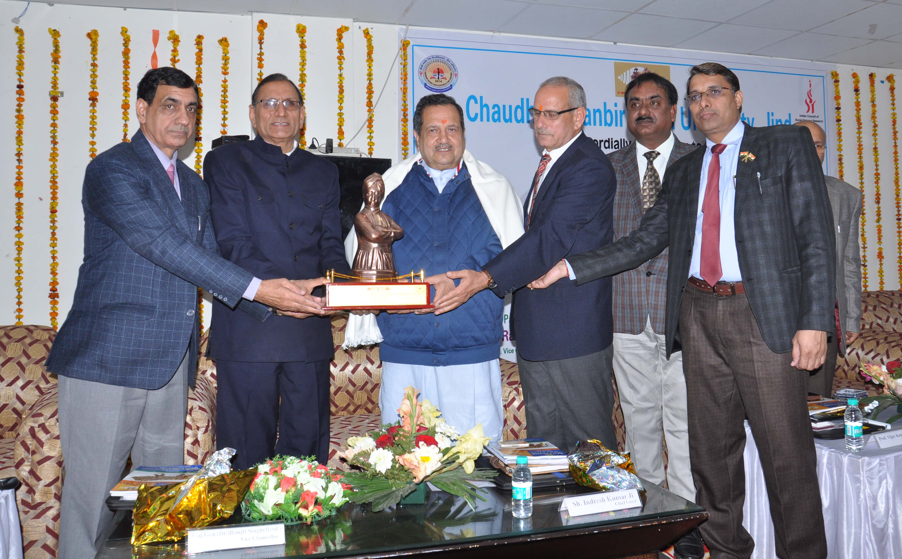
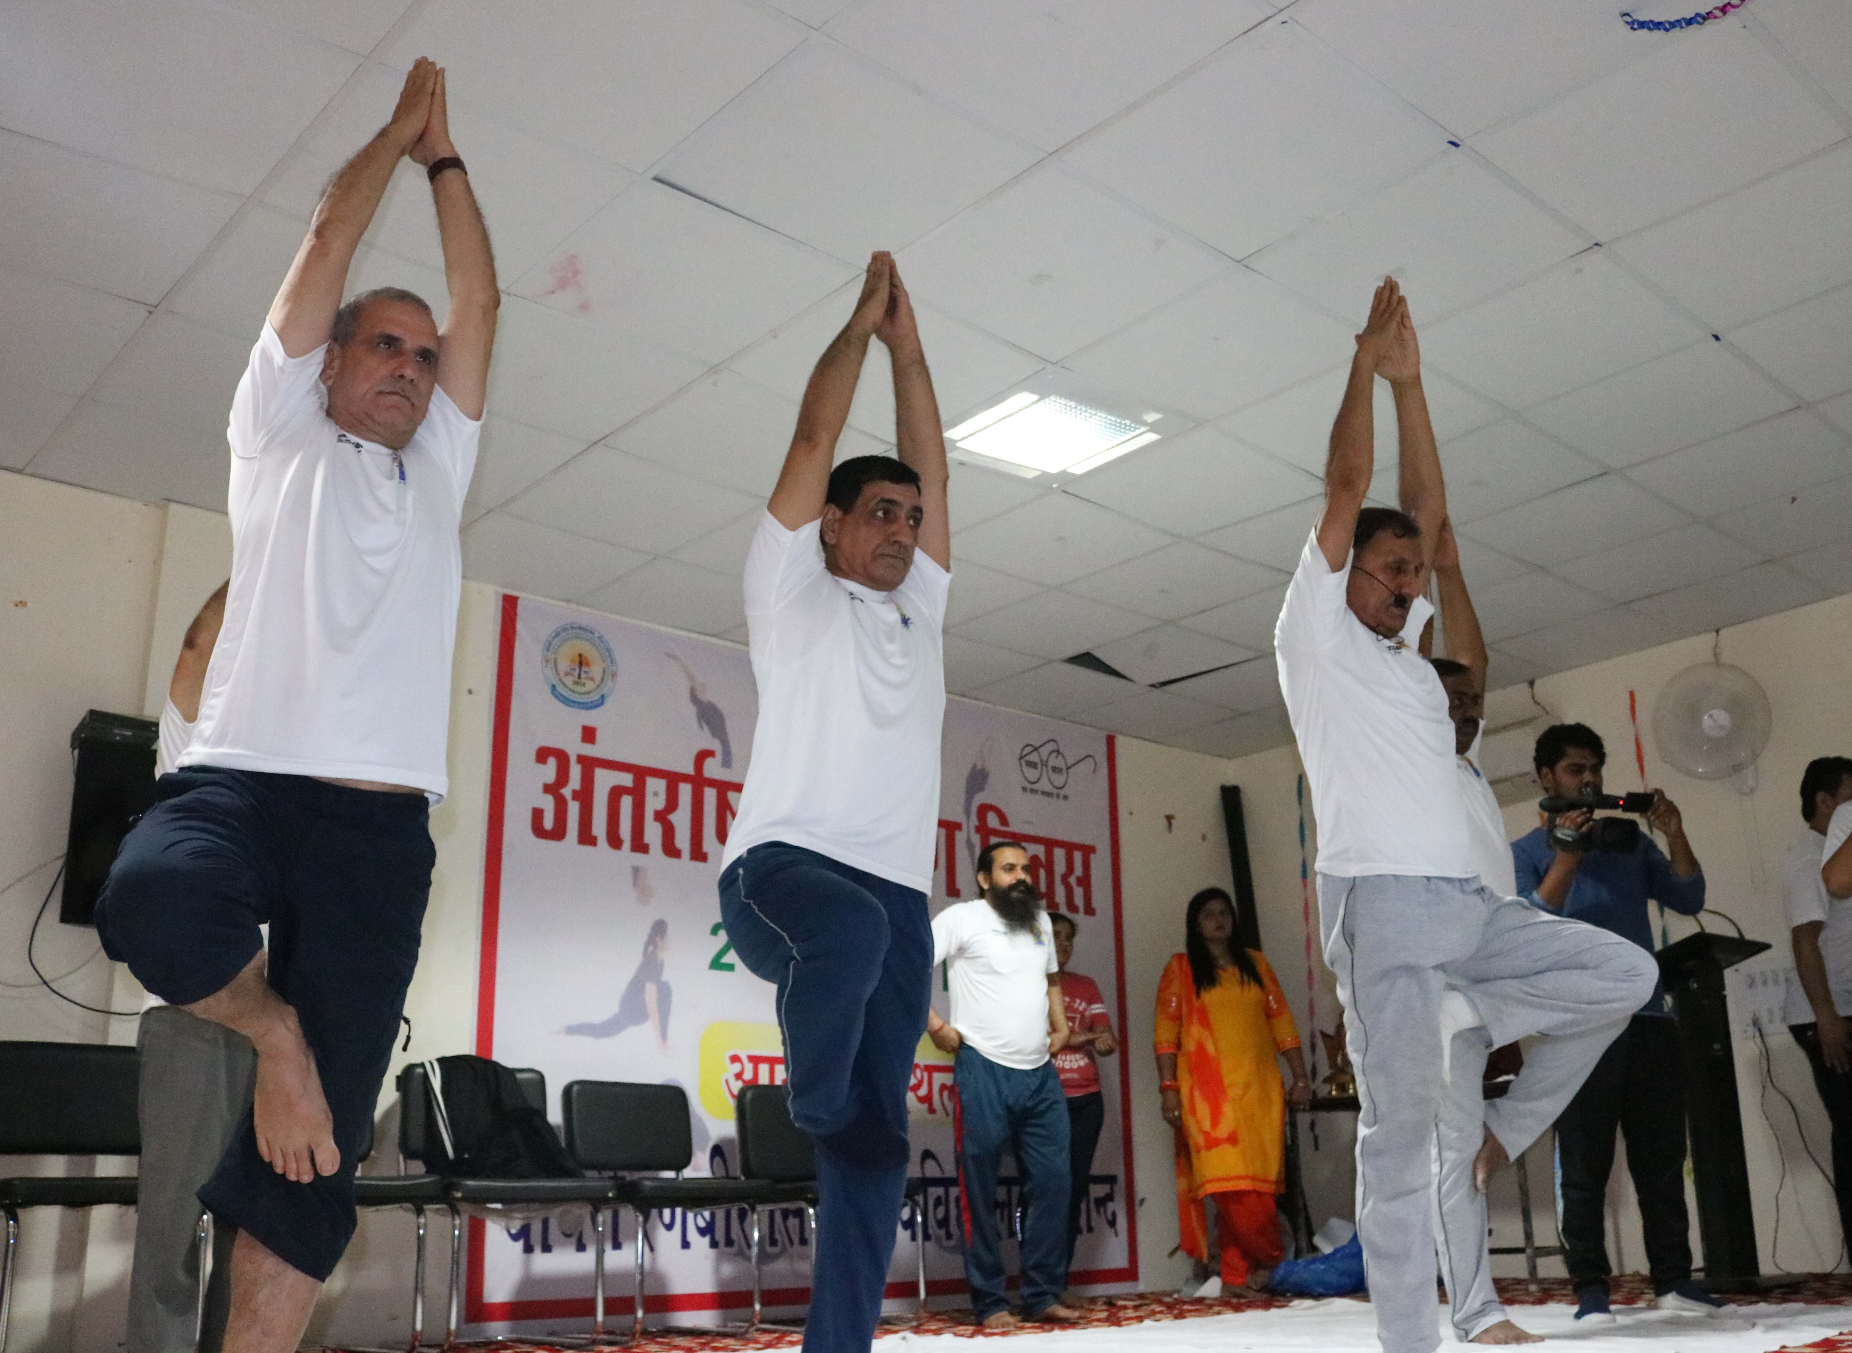

pkS/kjh j.kchj flag fo'ofo|ky;]thUn
Chaudhary Ranbir Singh University, Jind
(Established by the State Legislature Act 28 of 2014 and recognized U/S 2(f) & 12-B by UGC Act 1956)

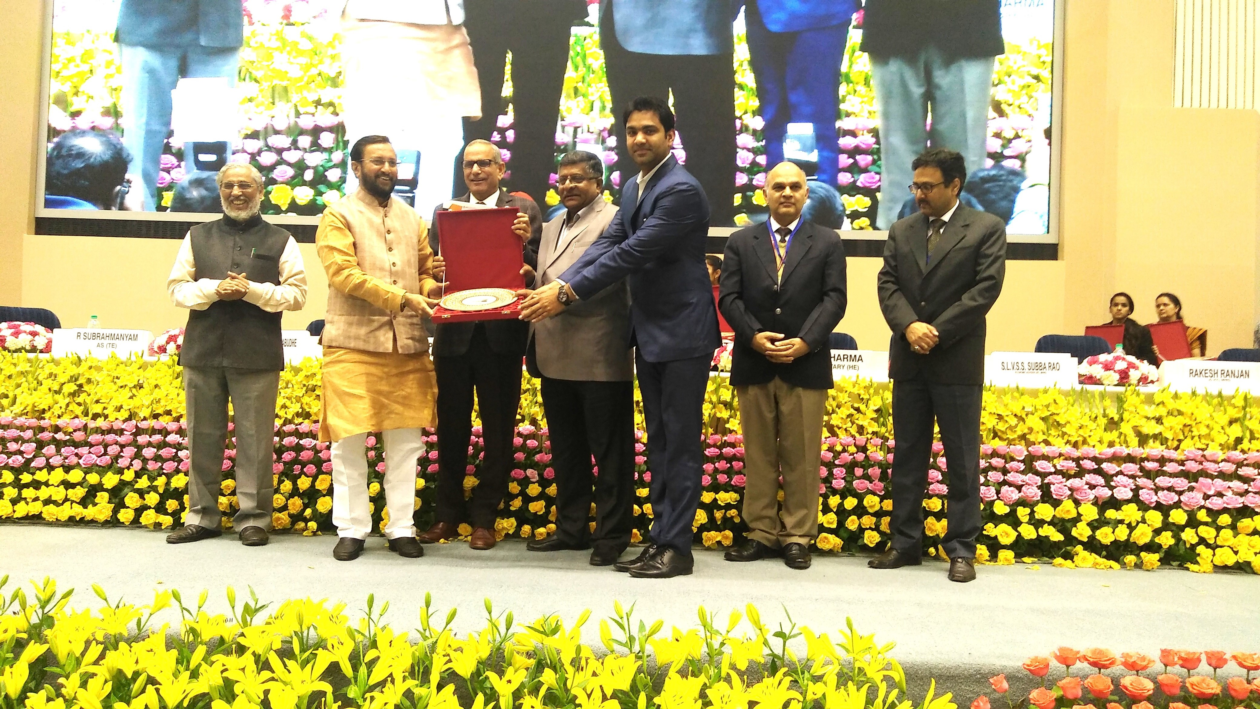

PROSPECTUS

For Admission to M.Ed. (Regular) Two Year (4 Semester) Course

Session - 2018-19

